**E-commerce Microservice Application (Assignment-2)**

**Team Name :-** 404 Not Found

**Team Members :-**

1. Yash Patel – N01537676
2. Jainish Patel - N01539567
3. Vijul Patel - N01549702
4. Shrey Shah - N01549811
5. **Backend (Microservices) :-**

**Repository :-** <https://github.com/yashpatel05/E-commerce-Microservice-Application/tree/main>

**Branch :-** main

* This repository contains the backend code for the E-commerce Microservice Application. The backend is implemented using microservices architecture with Spring Framework in Java.
* It includes separate microservices for managing products, orders, admin operations, and image retrieval.
* Containerization with Docker is utilized for each microservice and their respective databases.
* Communication between microservices is managed via REST APIs and Kafka.

**Functional Requirements :-**

**Products Service:** Manages product information including name, description, price, image id, and stock availability. Provides endpoints to create, delete, fetch and update products.

**Admin Service:** Manages admin operations such as creating, deleting, viewing, and updating products. Admins can also view all orders. Admin operations can be performed via Postman. Provides endpoints to manage products, orders and images.

**Orders Service:** Processes customer orders including receiving product selections and quantities, calculating total price, and updating product stock. Provides endpoints to manage orders.

**Image Service:** Retrieves product images based on image ID. Provides endpoints to manage images.

**Technical Requirements :-**

**Microservices:** Developed using Spring Framework.

**Containerization:** Docker containers for each microservice and their databases.

**API Gateway:** Implemented Gateway Service to manage external requests and route them to appropriate microservices.

**Database:** Separate Docker containers for each microservice's database using MySQL.

**Communication:** RESTful APIs and Kafka for asynchronous communication between microservices.

**Deployment :-**

Docker Compose is used to simplify deploying all microservices and their databases as a single unit.

**Testing Routes**

Testing routes for each microservice through Gateway service are provided below:

**Products Service**

* Test GET all products: <http://localhost:8080/products>

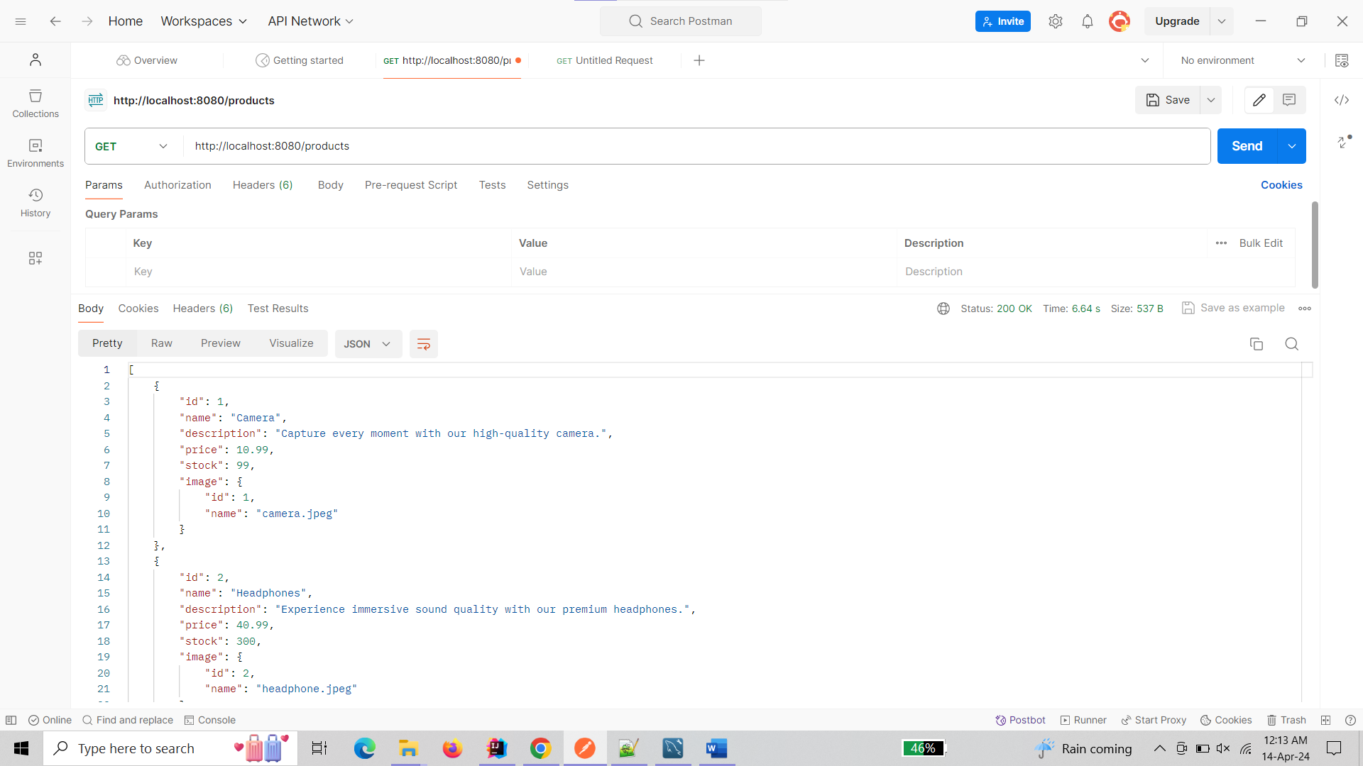

* Test GET product by ID: [http://localhost:8080/products/{id}](http://localhost:8080/products/%7bid%7d)

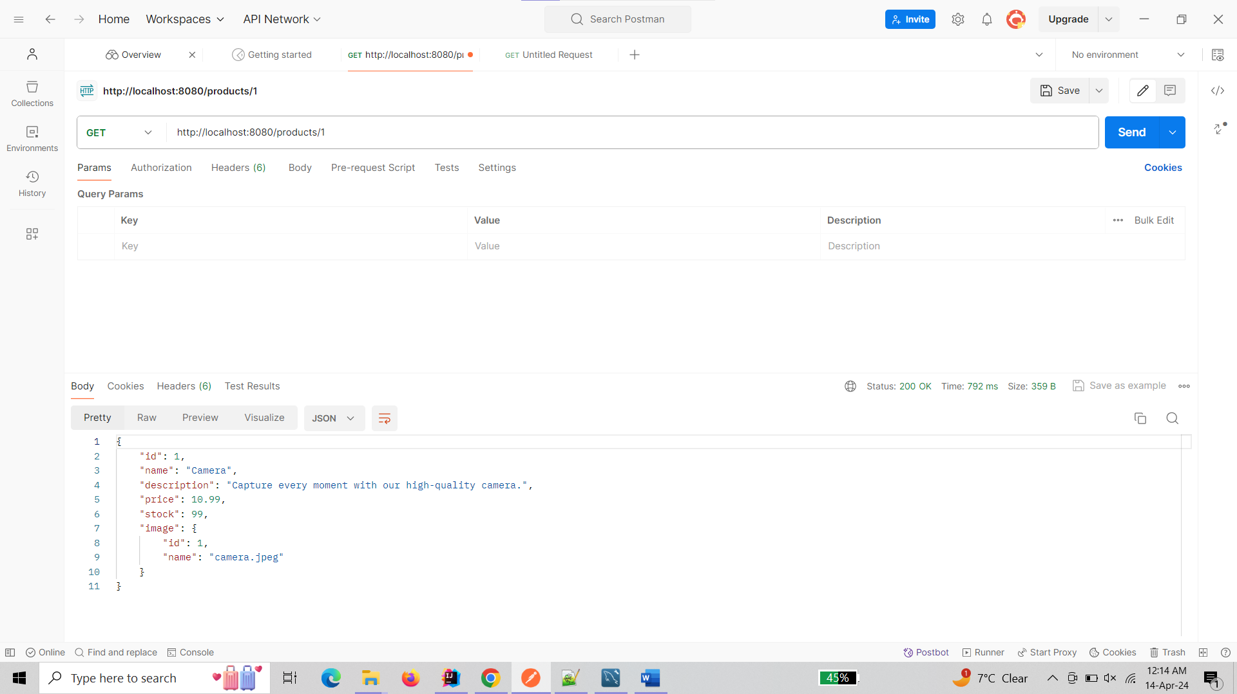

* Test POST create product: [http://localhost:8080/products](http://localhost:8080/products%20) (with JSON body)

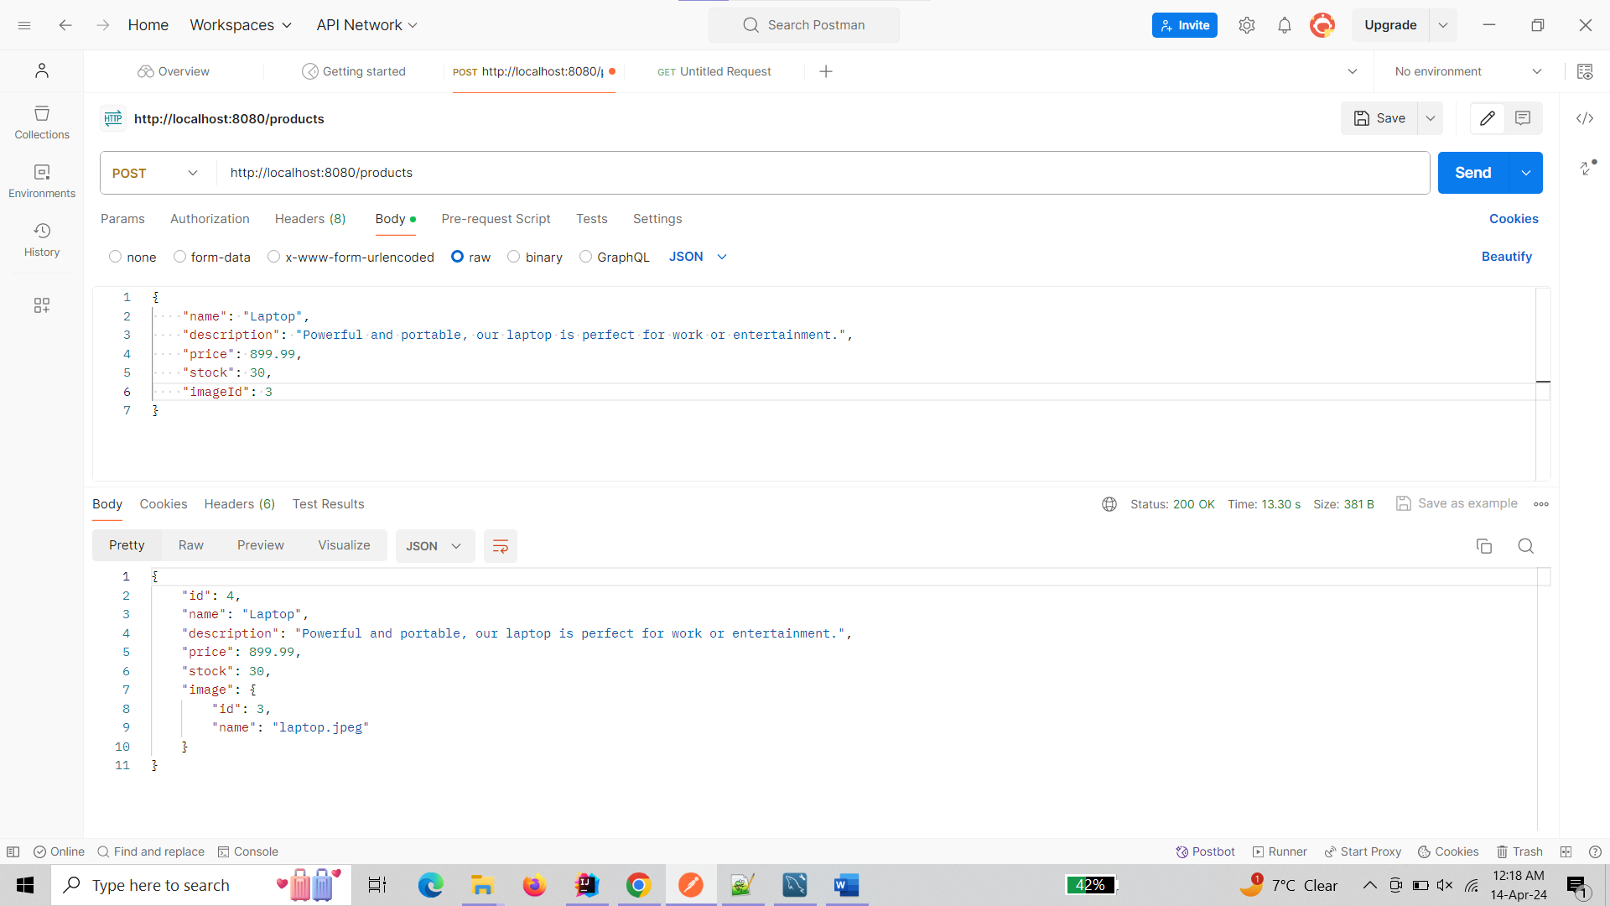

* Test PUT update product: [http://localhost:8080/products/{id}](http://localhost:8080/products/%7bid%7d%20) (with JSON body)

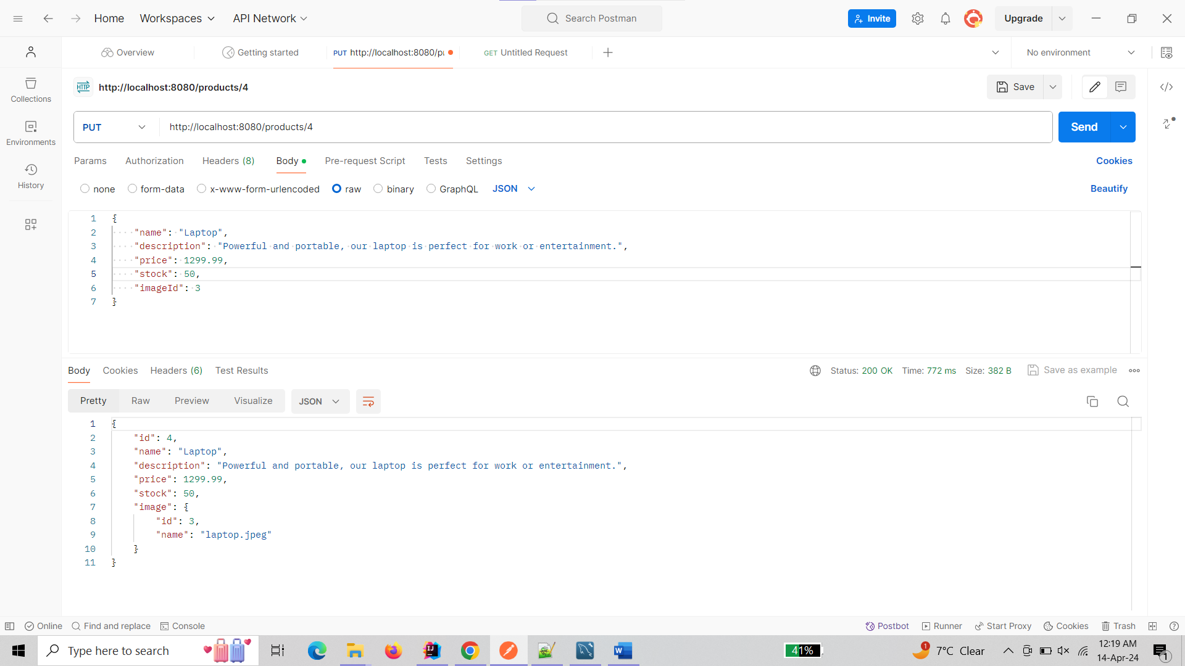

* Test DELETE delete product: [http://localhost:8080/products/{id}](http://localhost:8080/products/%7bid%7d)

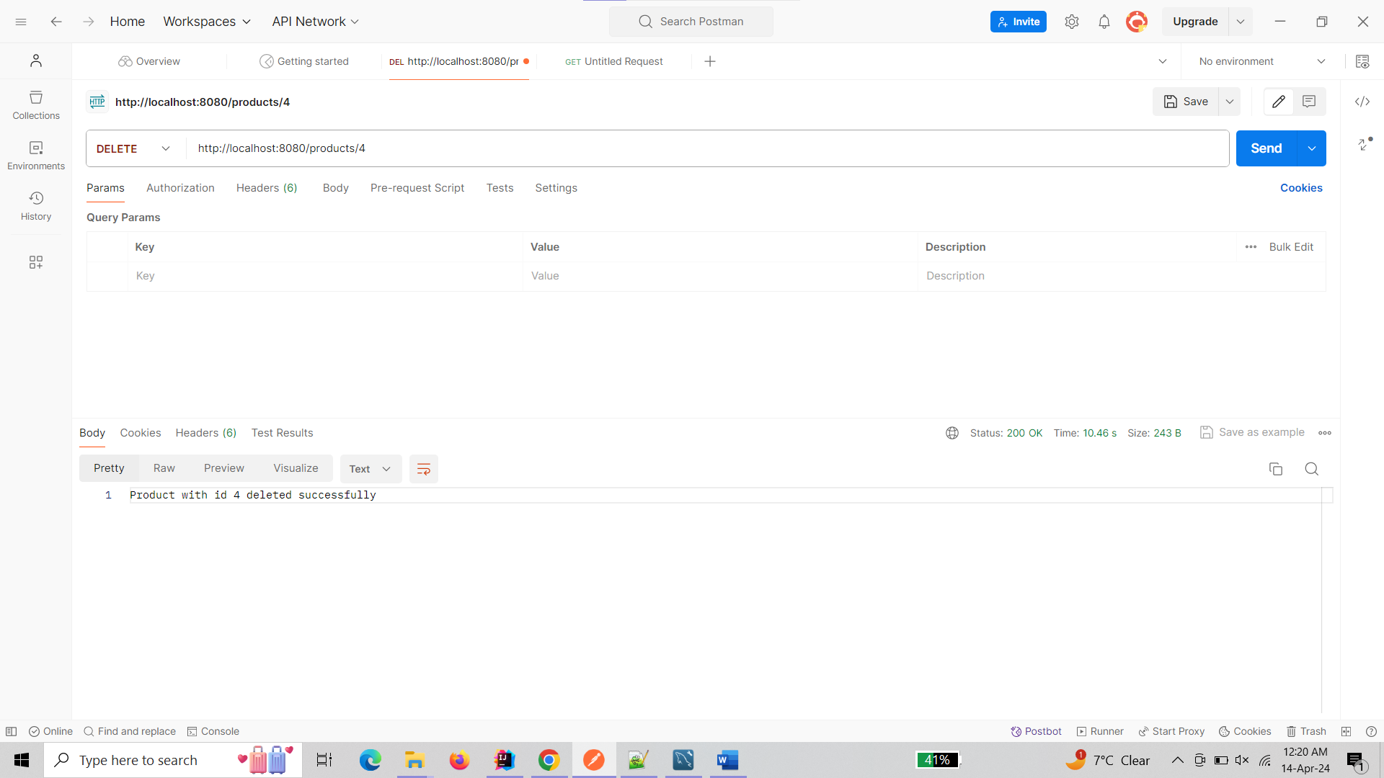

**Orders Service**

* Test GET all orders: <http://localhost:8080/orders>

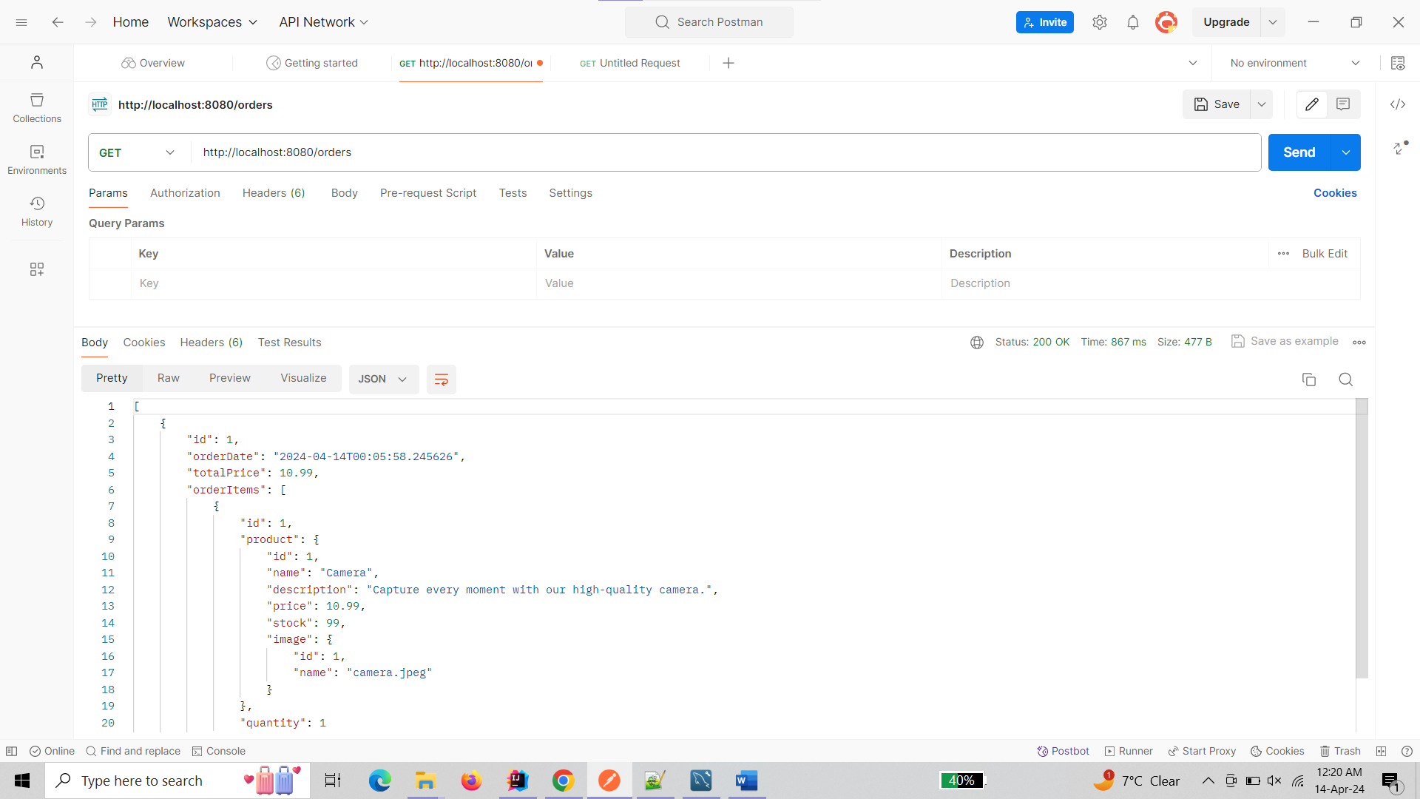

* Test GET order by ID: [http://localhost:8080/orders/{id}](http://localhost:8080/orders/%7bid%7d)

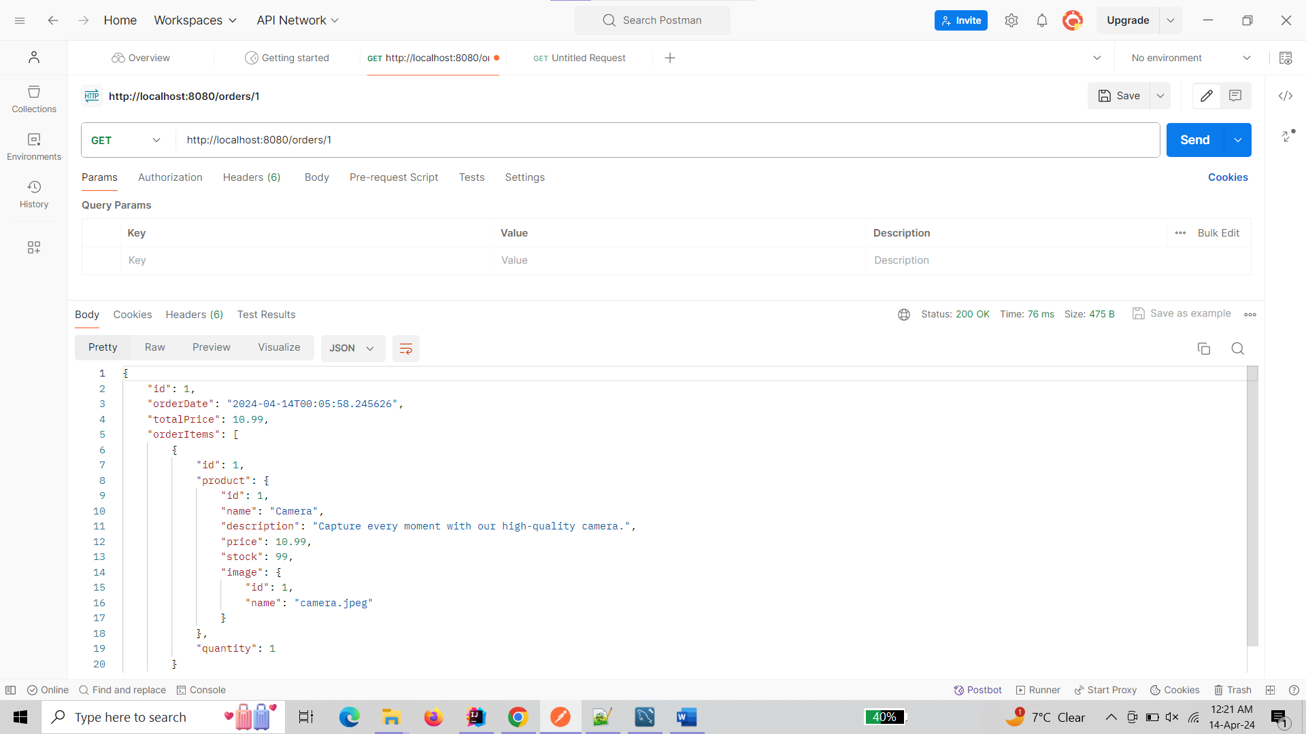

* Test POST create order: [http://localhost:8080/orders](http://localhost:8080/orders%20) (with JSON body)

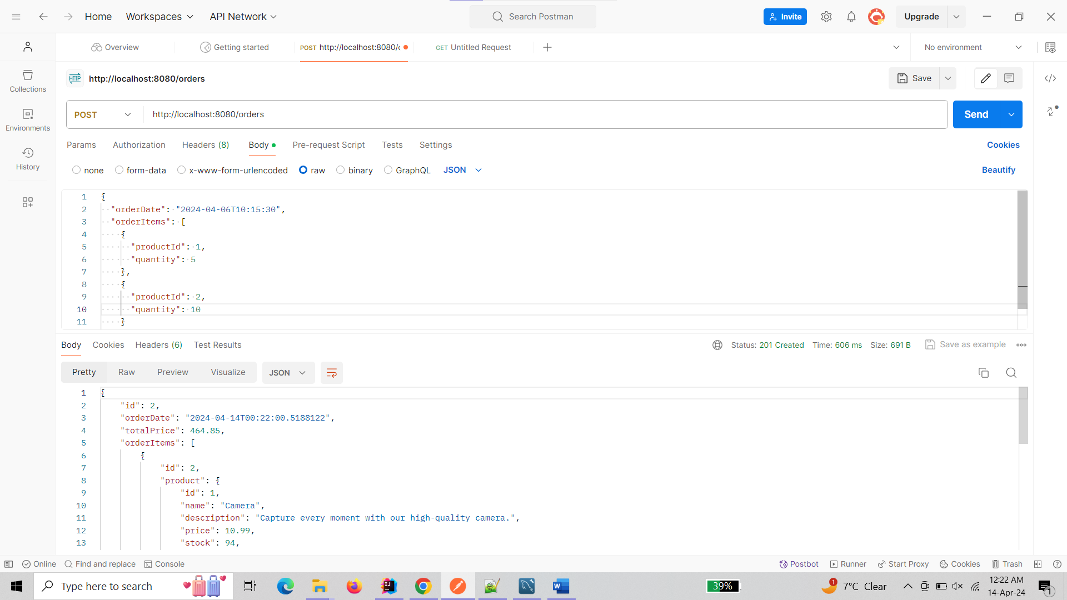

* Test DELETE delete order: [http://localhost:8080/orders/{id}](http://localhost:8080/orders/%7bid%7d)

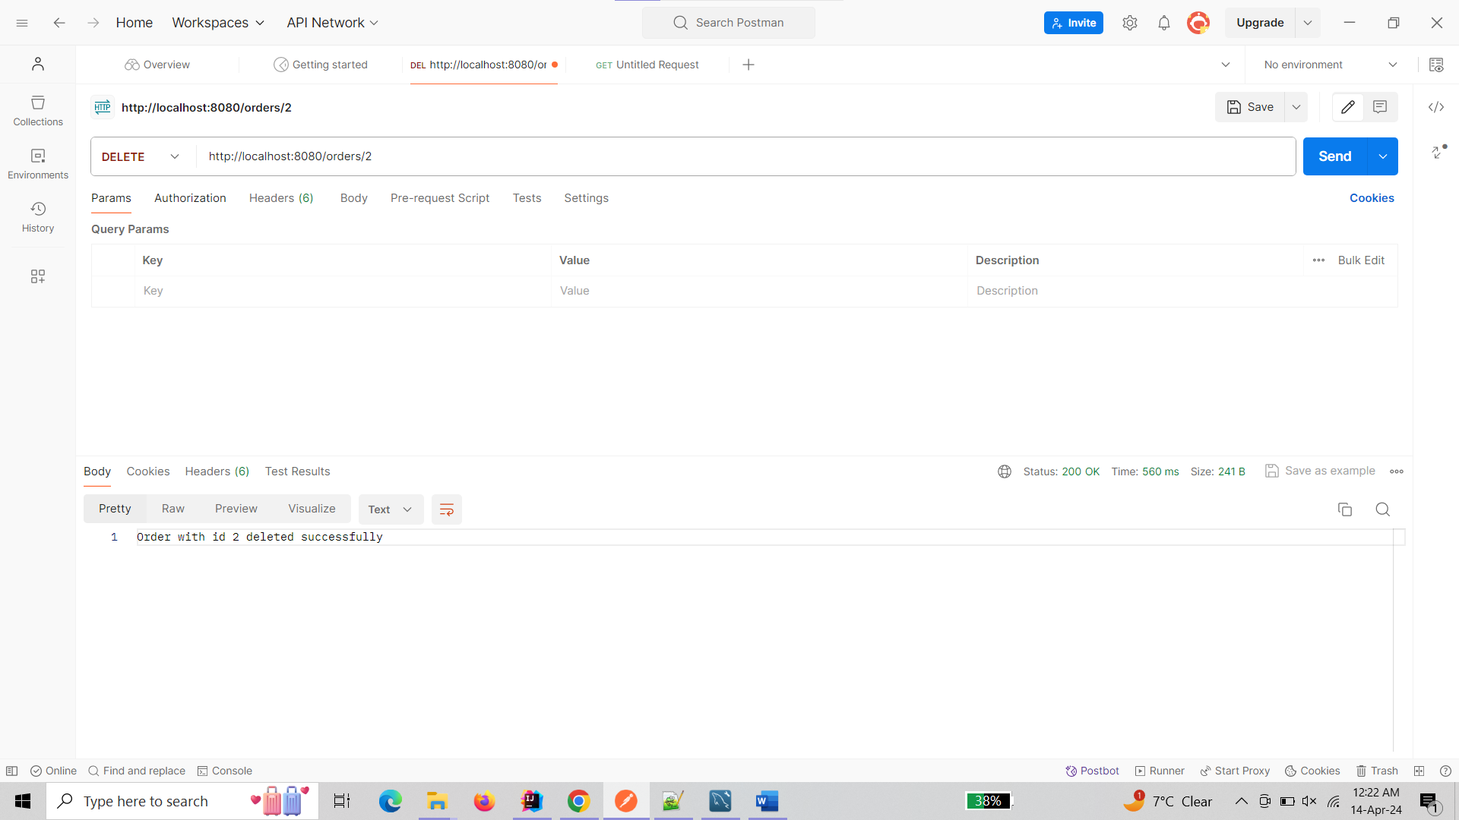

**Admin Service**

* Test GET all products: <http://localhost:8080/admin/products>

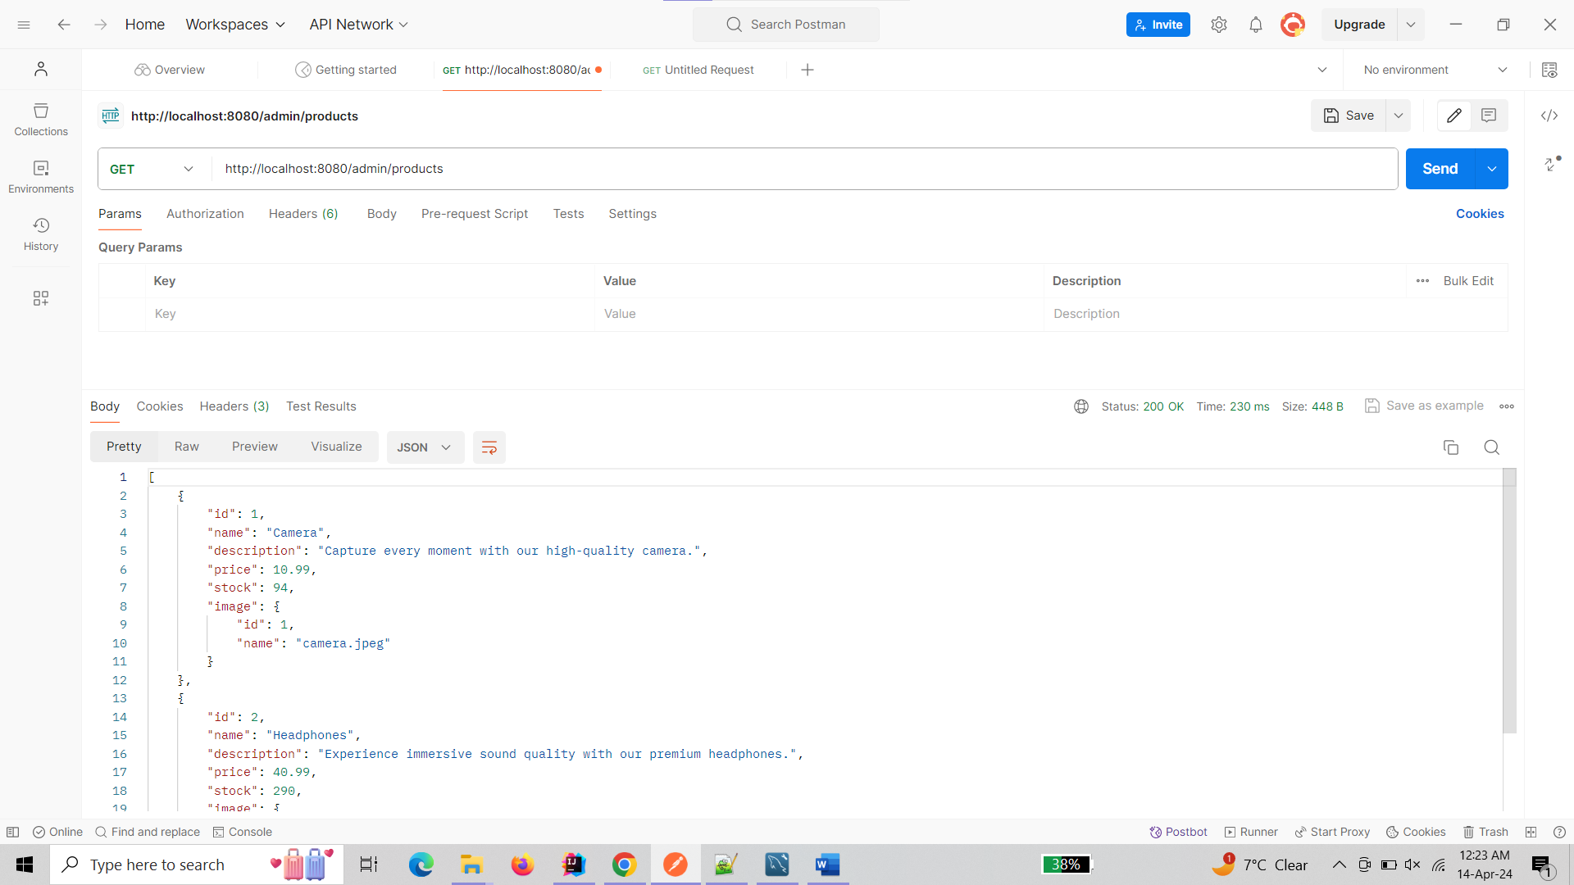

* Test GET product by ID: [http://localhost:8080/admin/products/{id}](http://localhost:8080/admin/products/%7bid%7d)

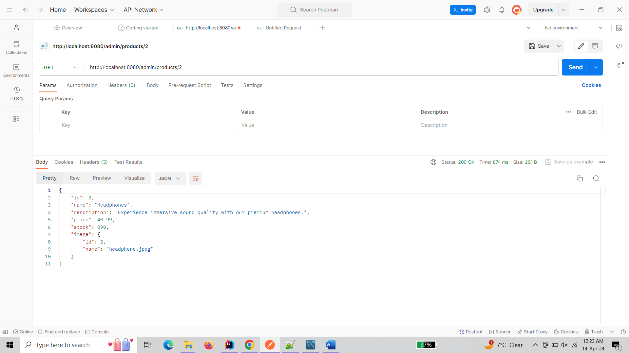

* Test POST create product: <http://localhost:8080/admin/products> (with JSON body)

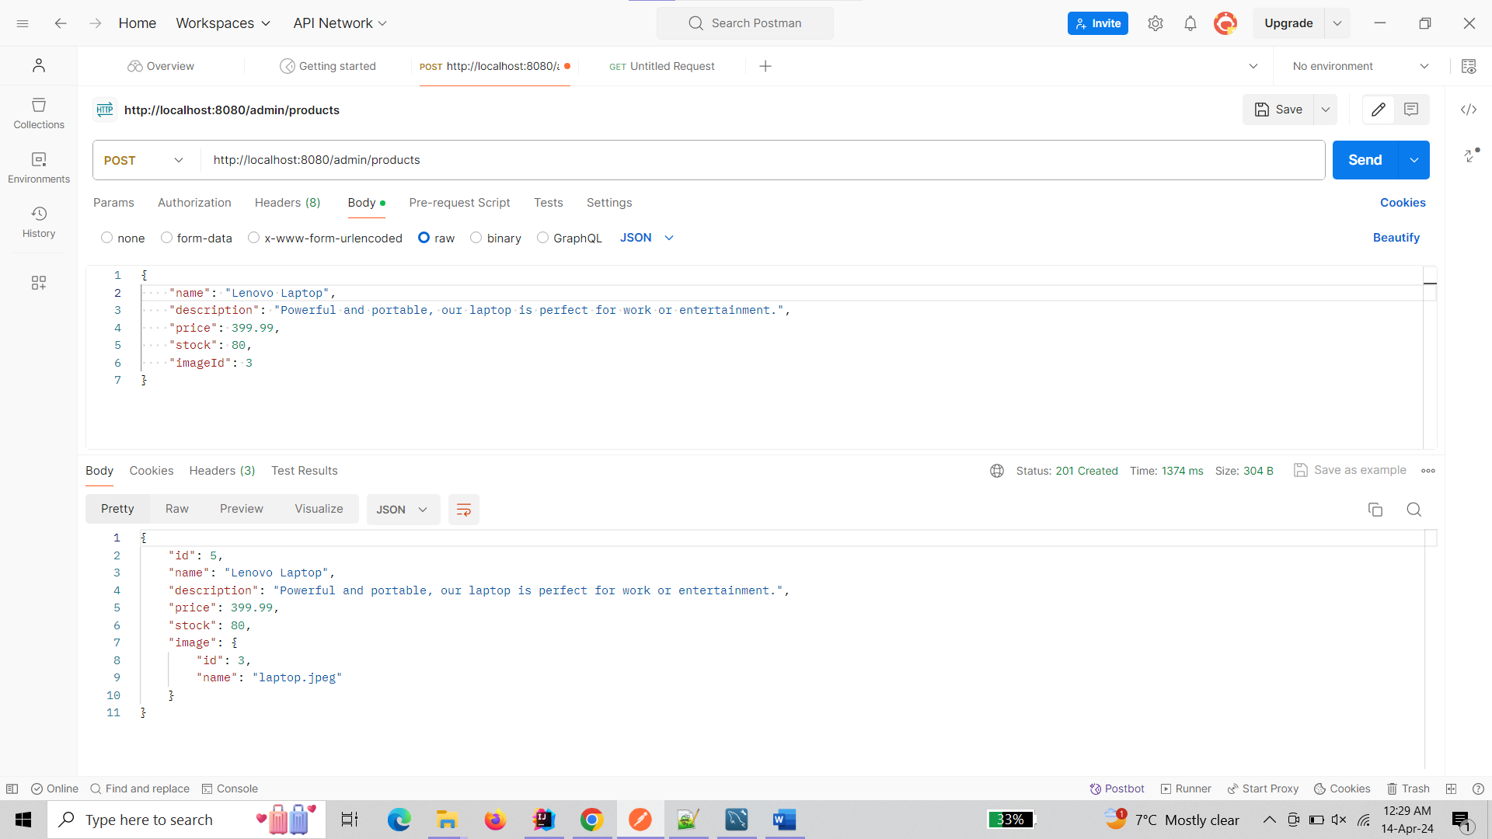

* Test PUT update product: [http://localhost:8080/admin/products/{id}](http://localhost:8080/admin/products/%7bid%7d) (with JSON body)

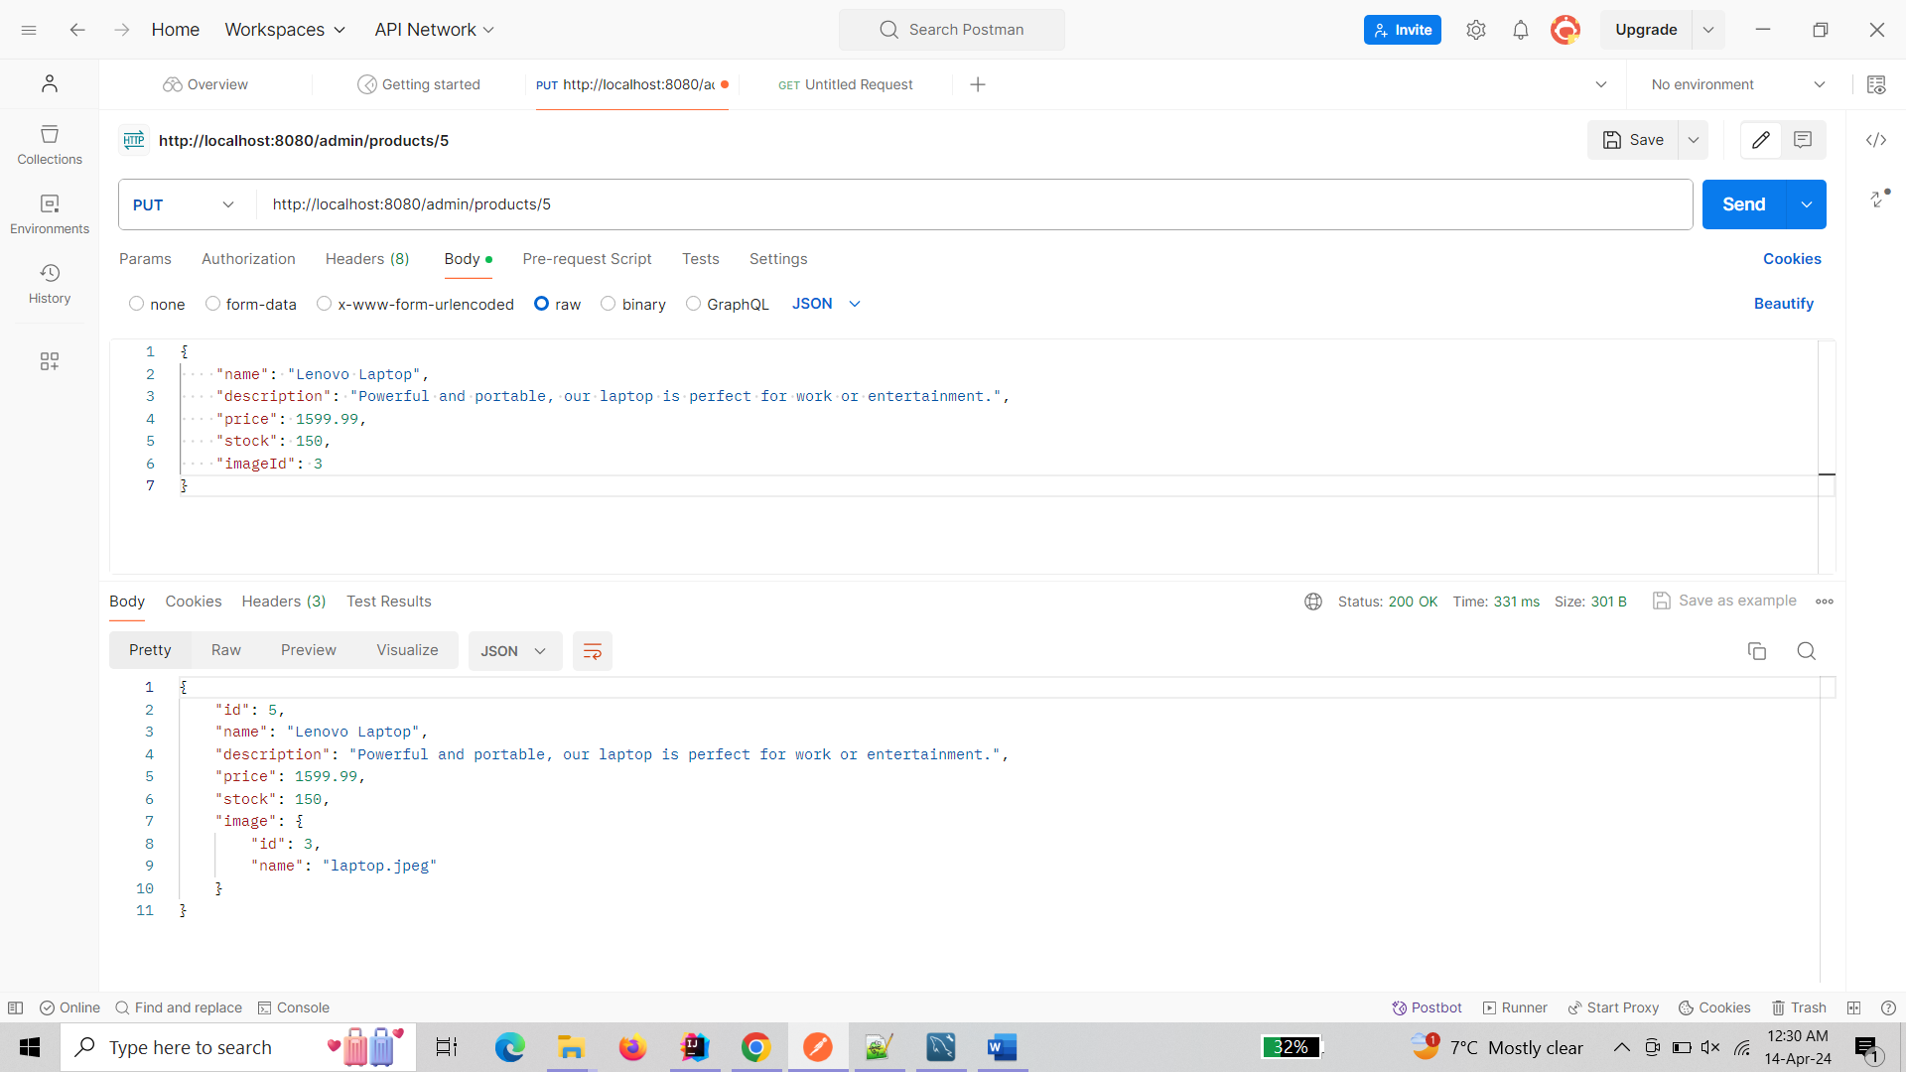

* Test DELETE delete product: [http://localhost:8080/admin/products/{id}](http://localhost:8080/admin/products/%7bid%7d)

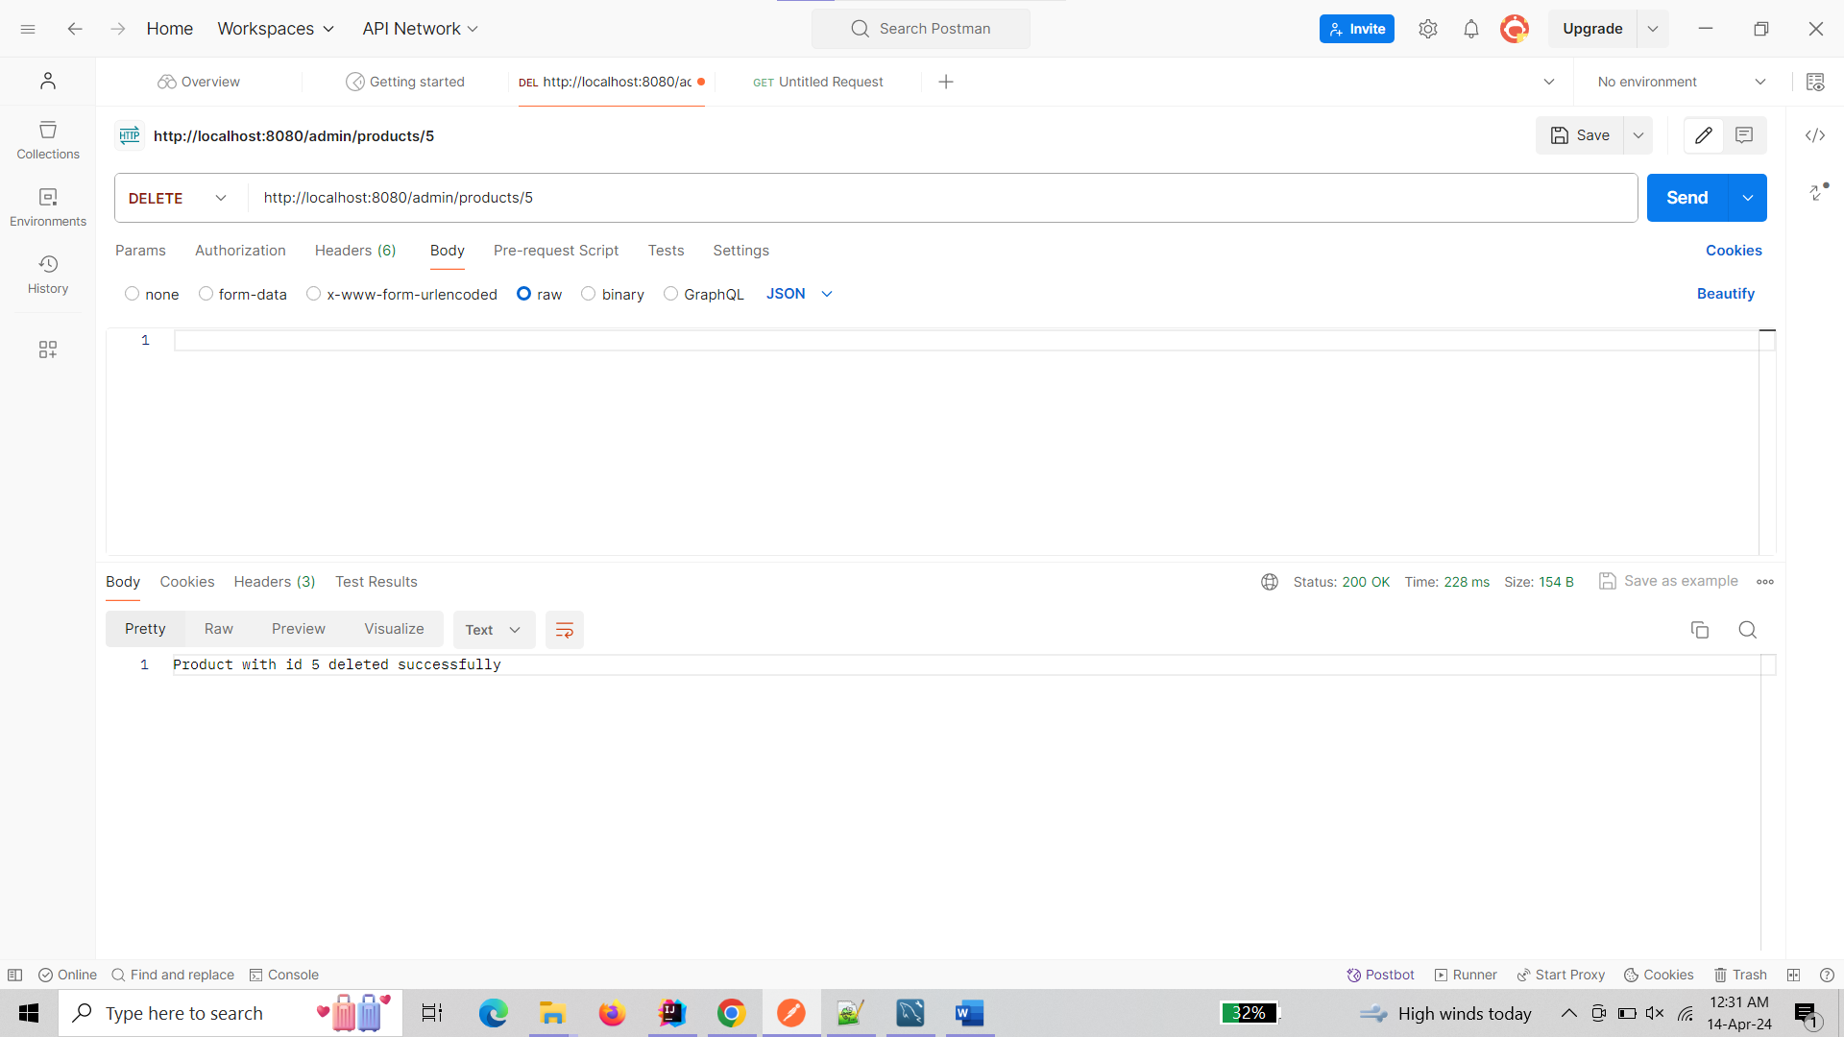

* Test GET all orders: <http://localhost:8080/admin/orders>

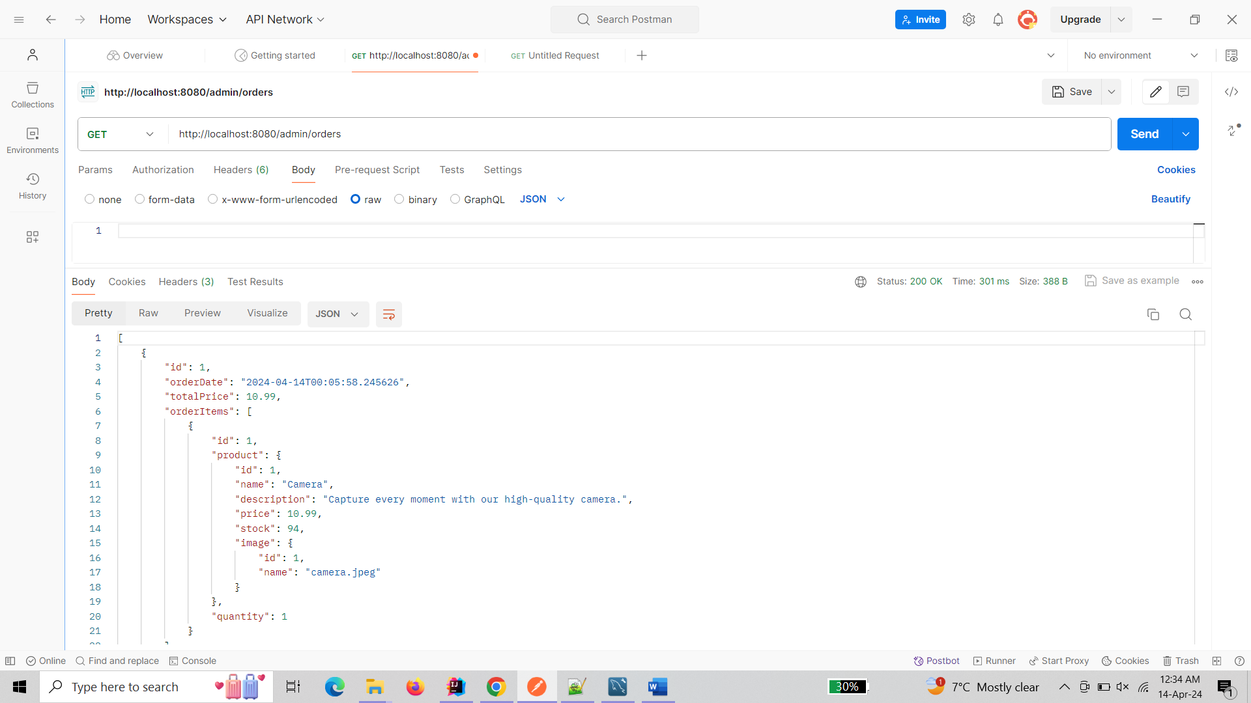

* Test POST create image: <http://localhost:8080/admin/images/add> (with JSON body)

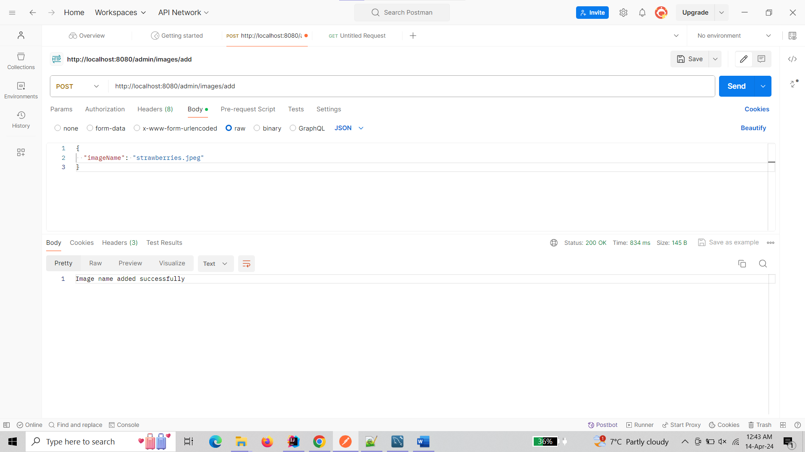

* Test GET all images: <http://localhost:8080/admin/images>

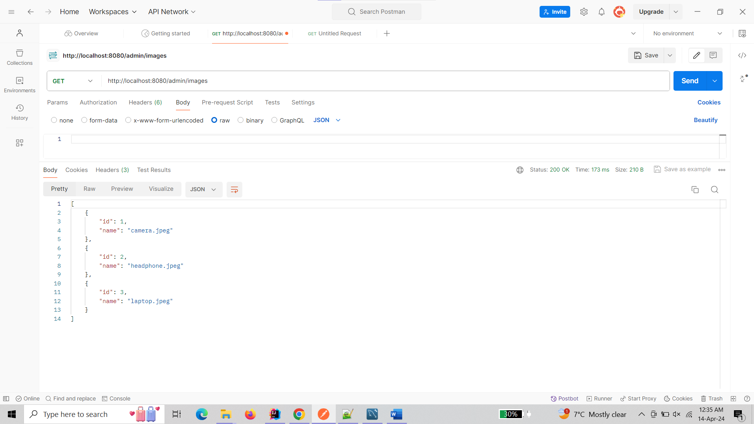

* Test GET image by ID: [http://localhost:8080/admin/images/{imageId}](http://localhost:8080/admin/images/%7bimageId%7d)

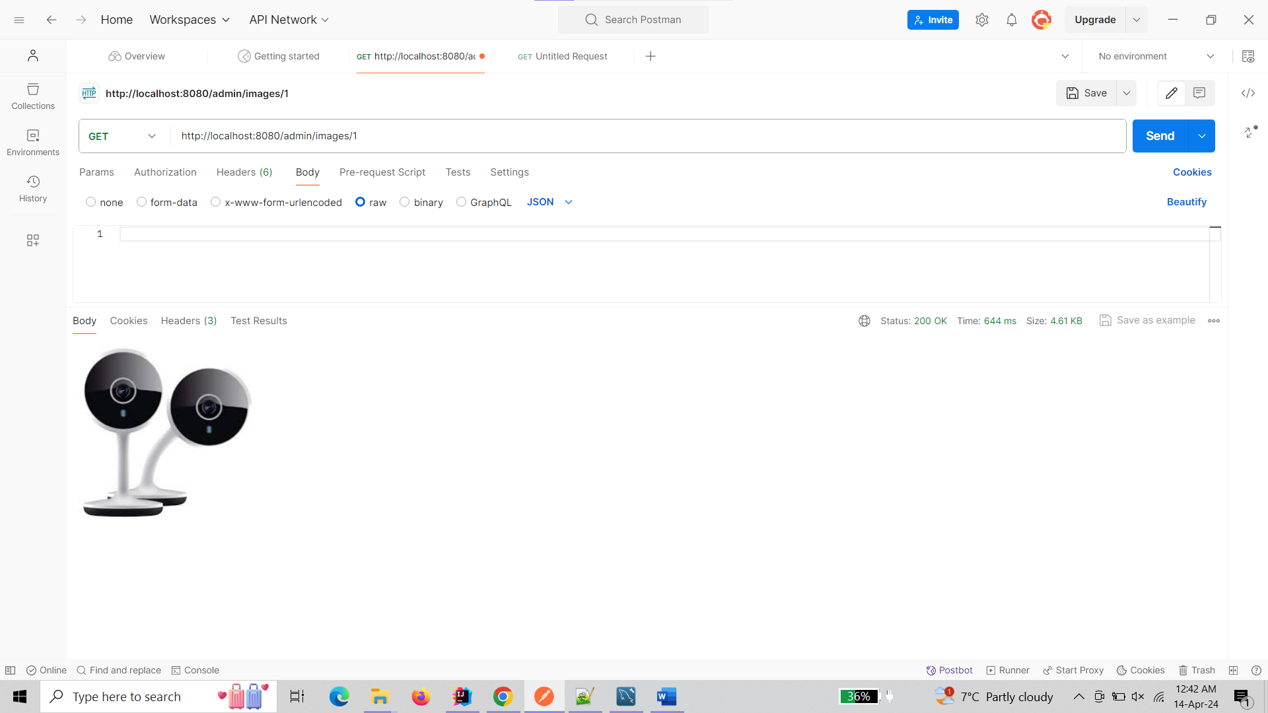

* Test DELETE delete image: [http://localhost:8080/admin/images/{imageId}](http://localhost:8080/admin/images/%7bimageId%7d)

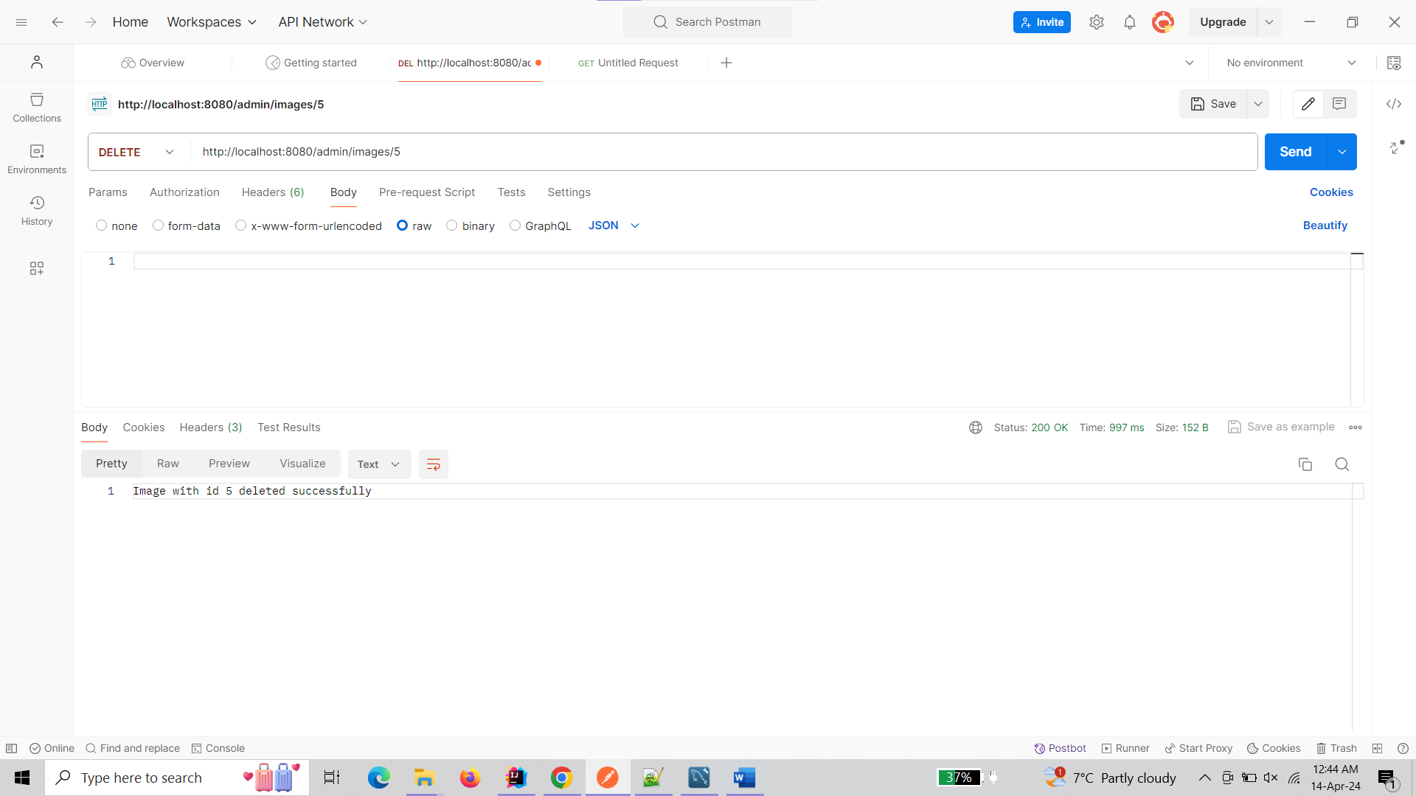

**Image Service**

* Test POST create image: <http://localhost:8080/images/add> (with JSON body)

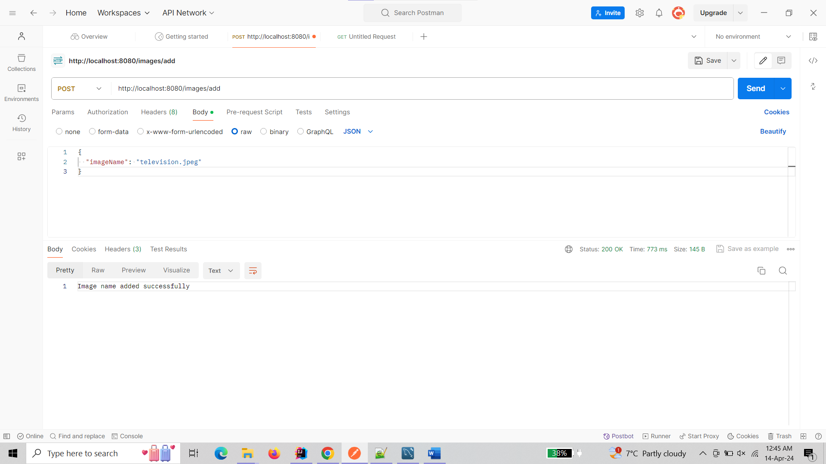

* Test GET image by ID: [http://localhost:8080/images/{imageId}](http://localhost:8080/images/%7bimageId%7d)

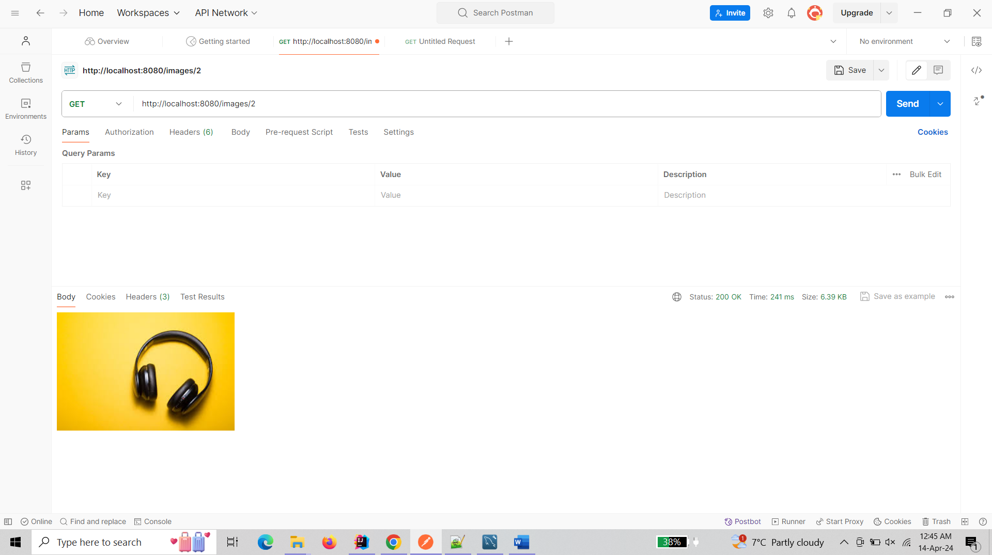

1. **Frontend UI**

**Repository :-** <https://github.com/yashpatel05/E-commerce-Microservice-Application/tree/frontend>

**Branch :-** frontend

* This branch contains the frontend code for the E-commerce Microservice Application. The frontend is developed using Next.js, a React framework, and provides a user interface for browsing products, viewing product details, managing the cart, and placing orders.

**Features :-**

* Browse products
* View product details
* Add products to cart
* Remove products from cart
* Place orders

**Getting Started :-**

To run the frontend locally, follow these steps:

* Clone this repository to your local machine.
* Switch to the frontend branch.
* Navigate to the ‘E-commerce-Microservice-Application’ directory.
* Install dependencies by running “npm install”
* Start the development server by running “npm run dev”
* Access the frontend application at <http://localhost:3000>

**Usage :-**

Once the frontend server is running, you can access the application in your web browser. Here are some key endpoints:

* Home: / - Displays project description and team members' names

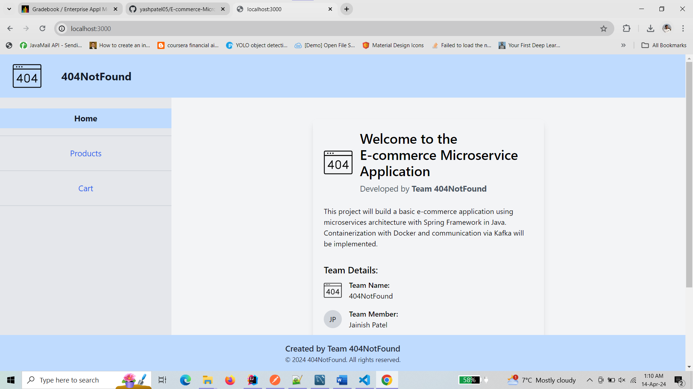

* All Products Details: /products - Displays all available products.

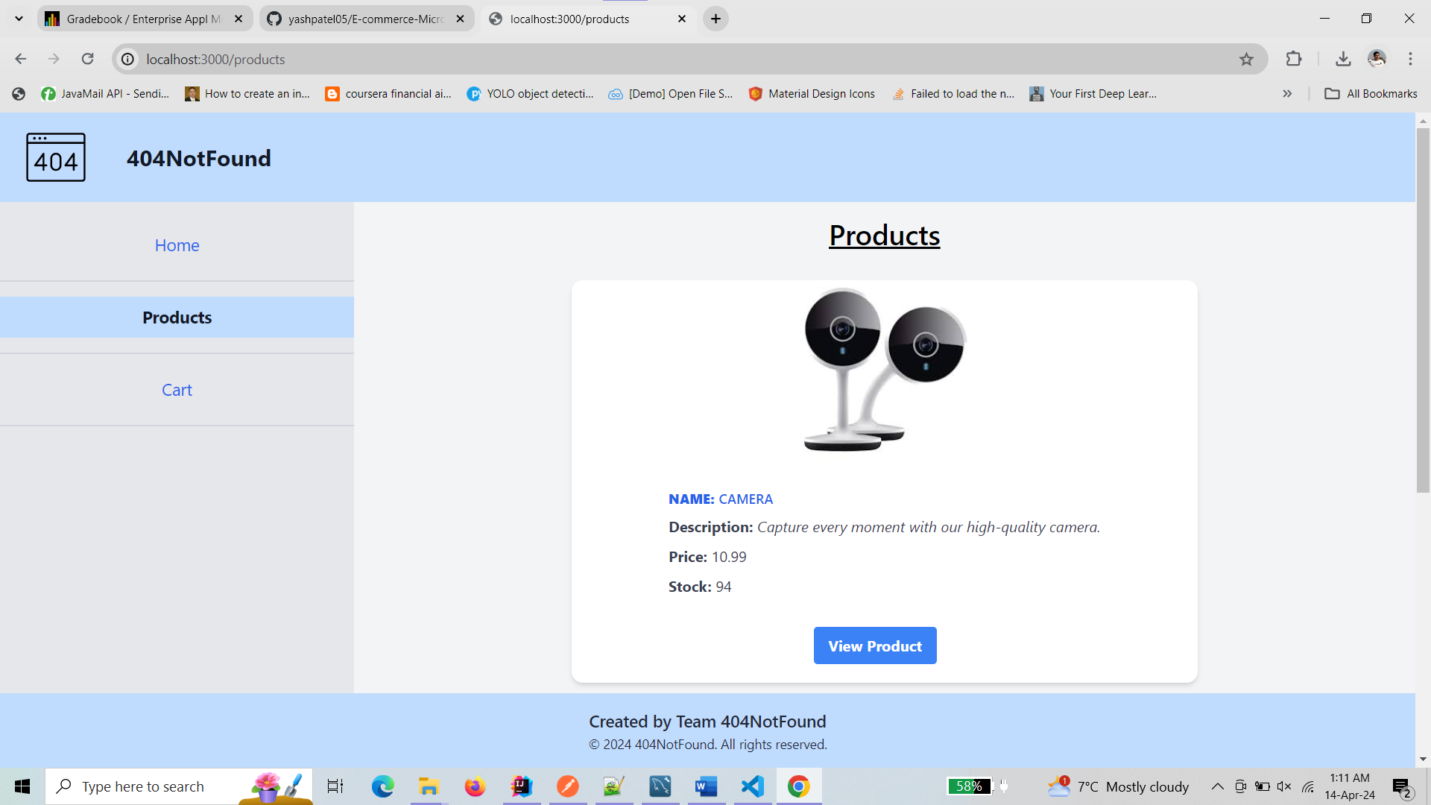

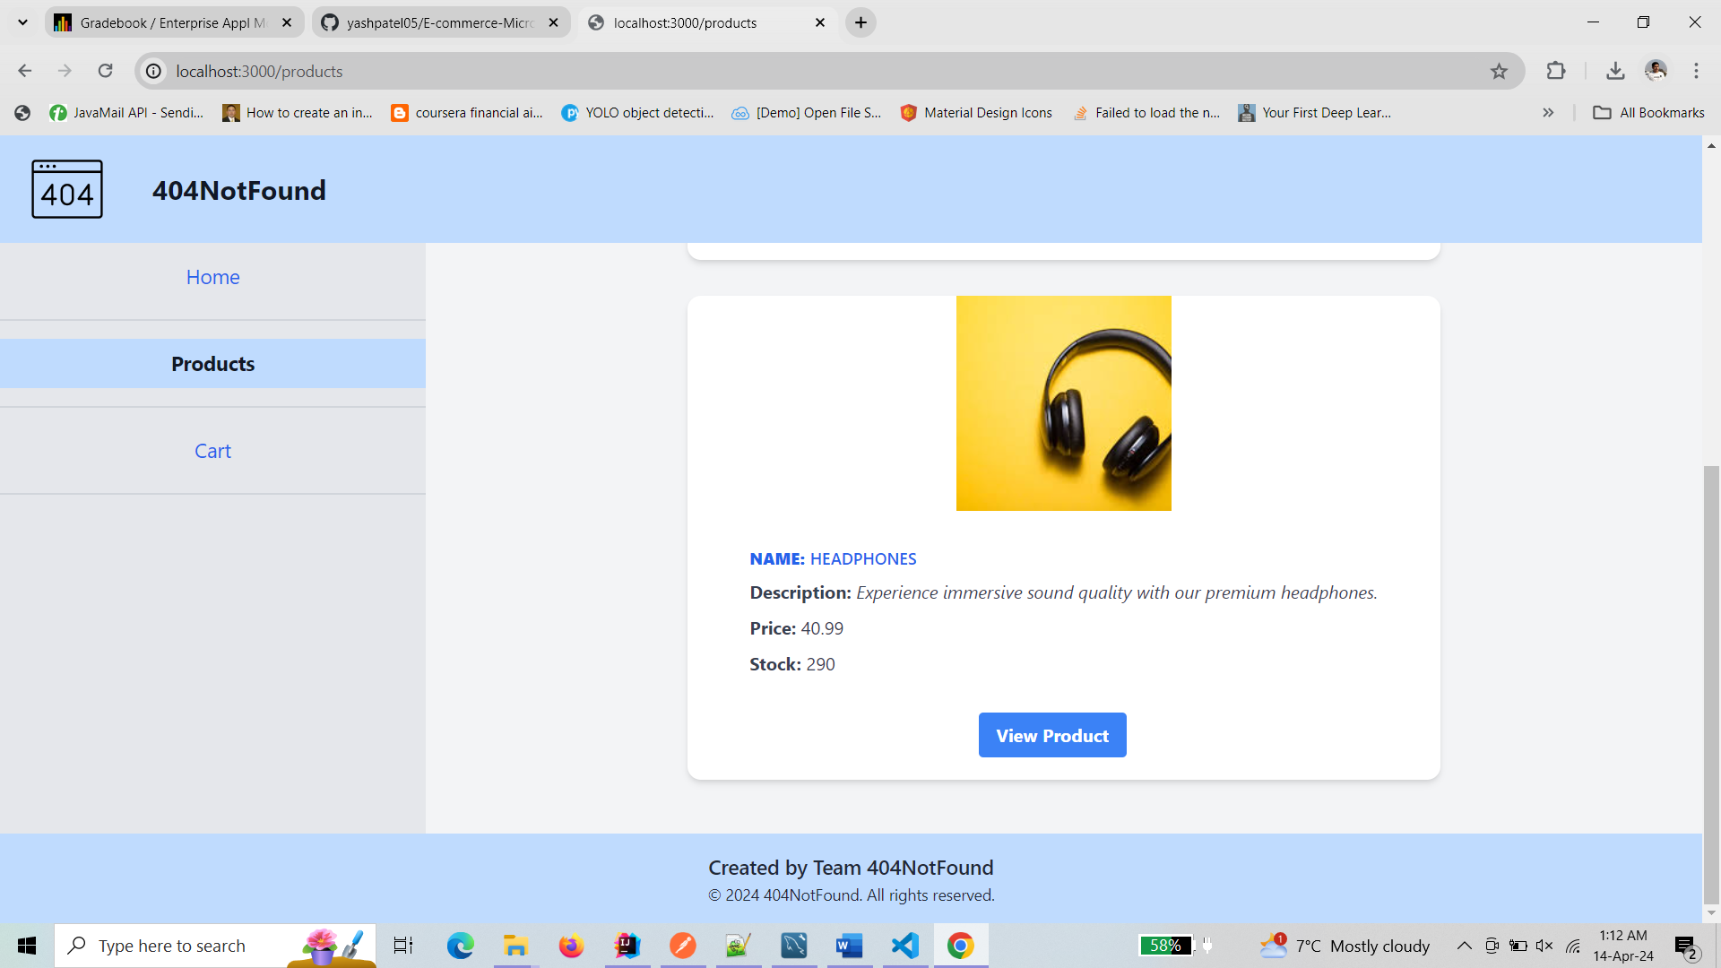

* Specific Product Detail: /products/[productId] - Displays details of a specific product.

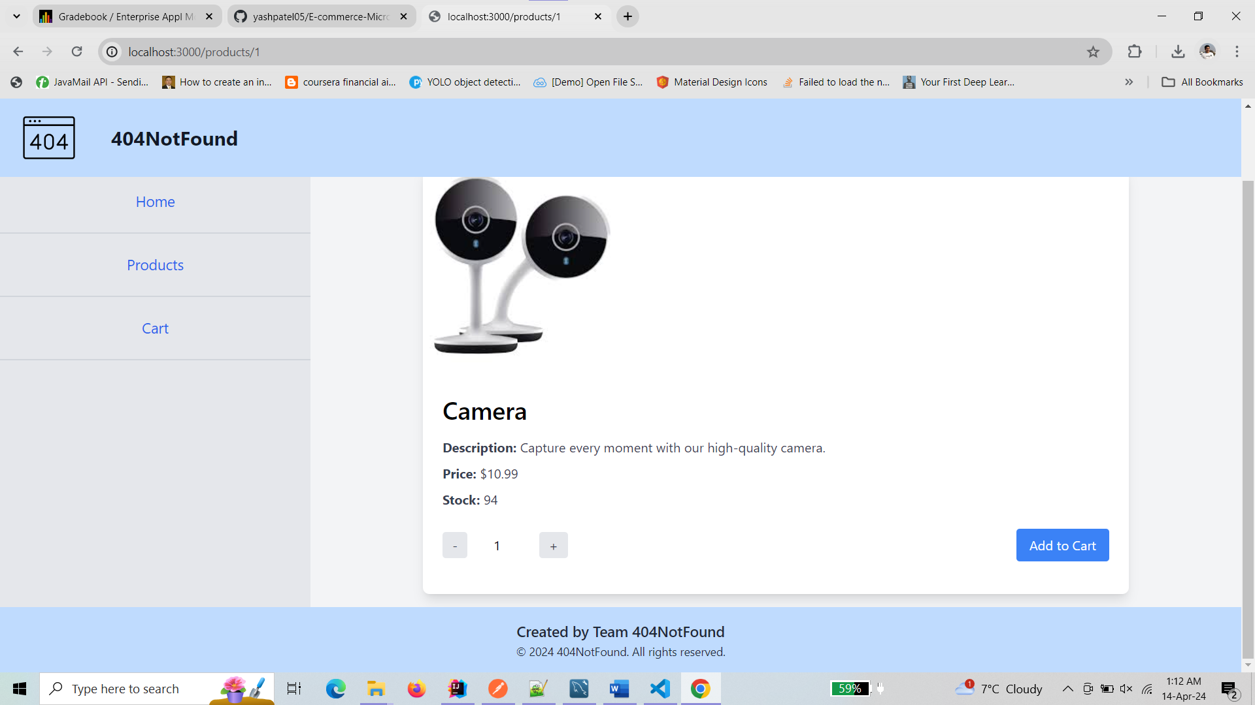

* Cart: /cart - Displays the current cart contents and allows users to manage items.

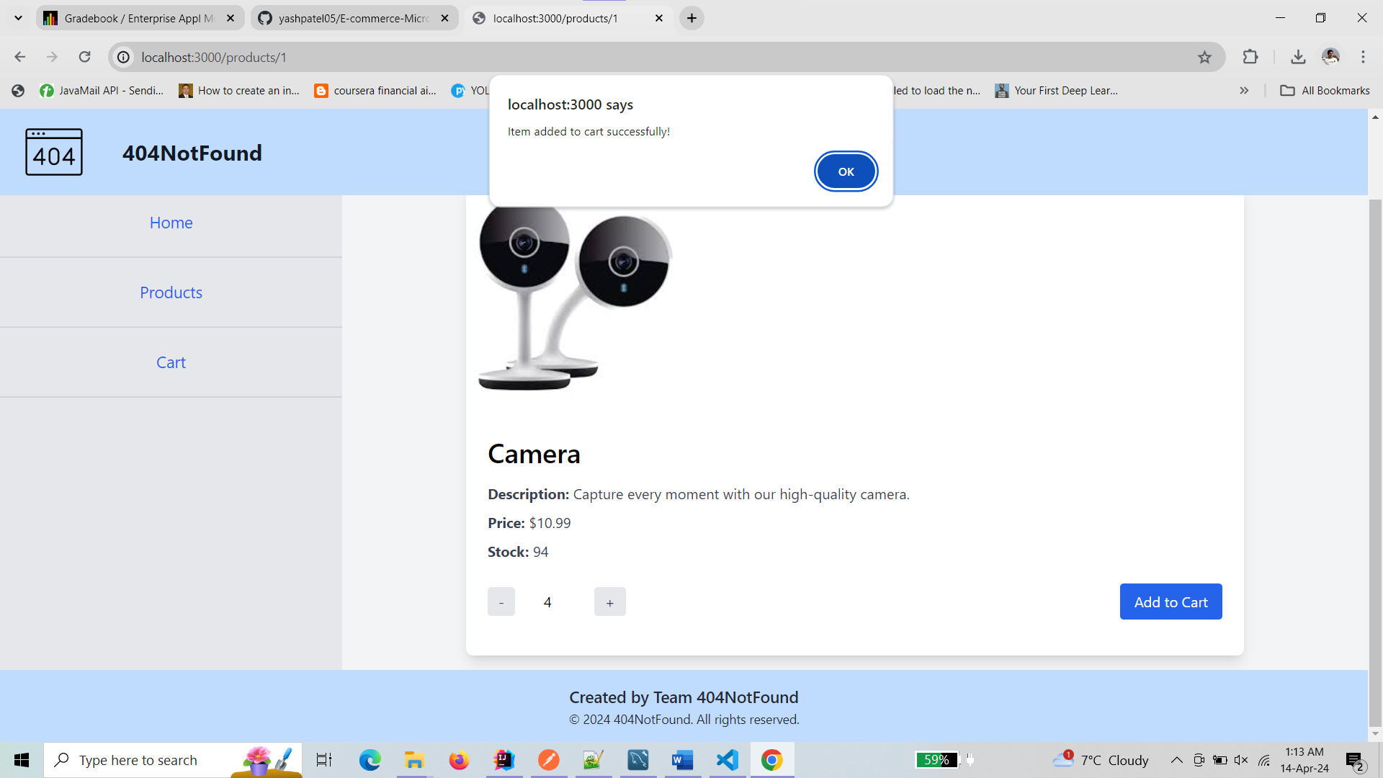

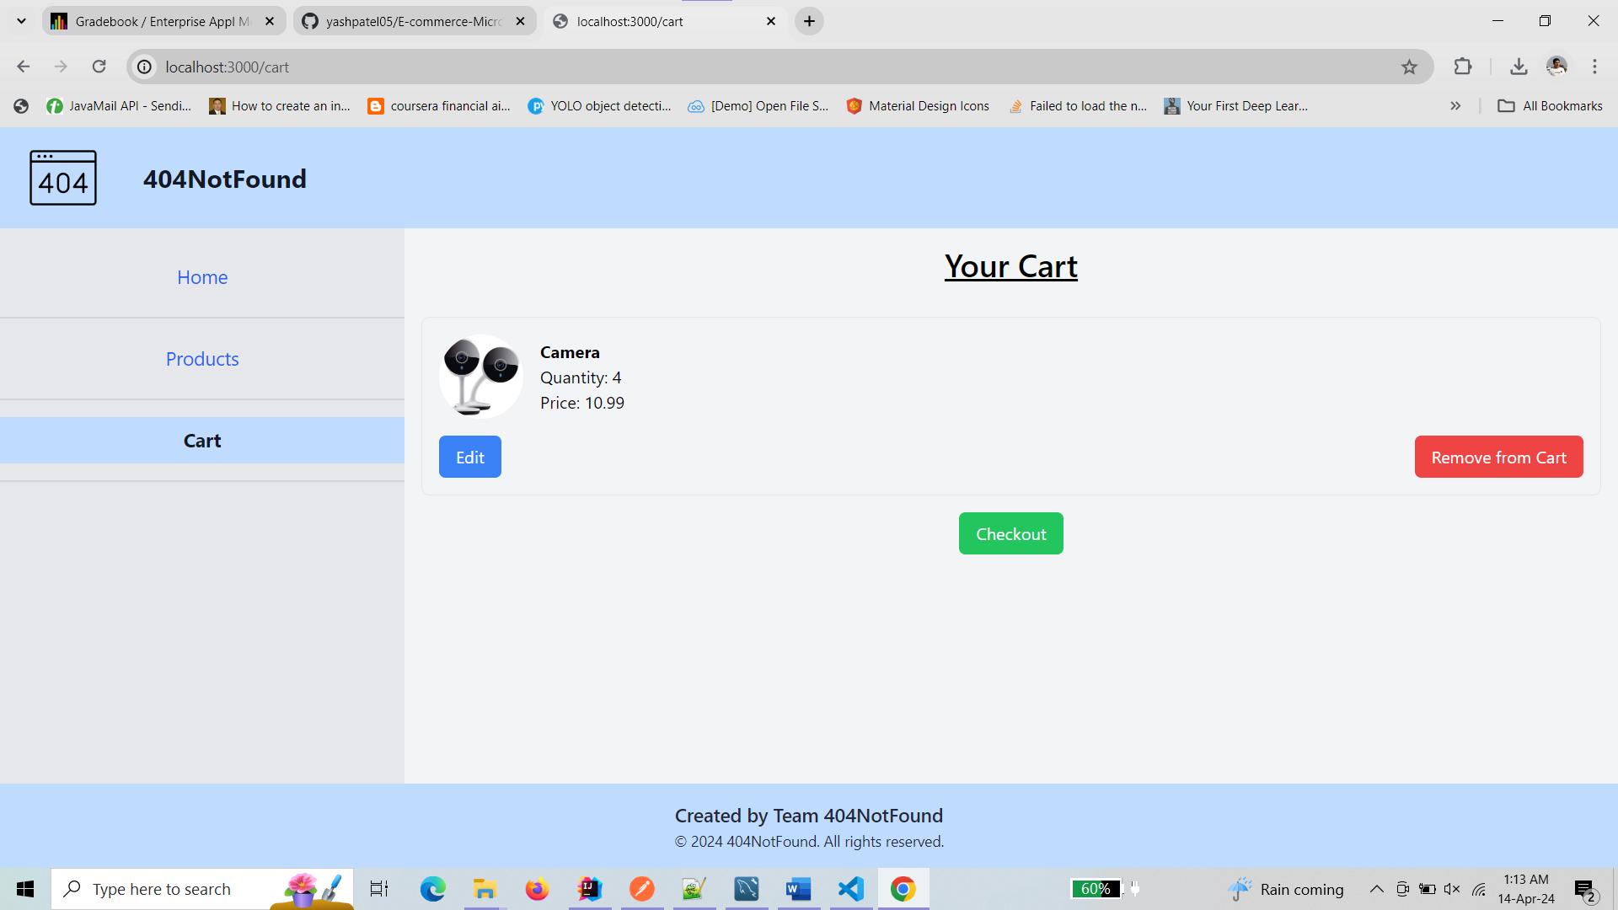

* Remove: - remove the item from the cart

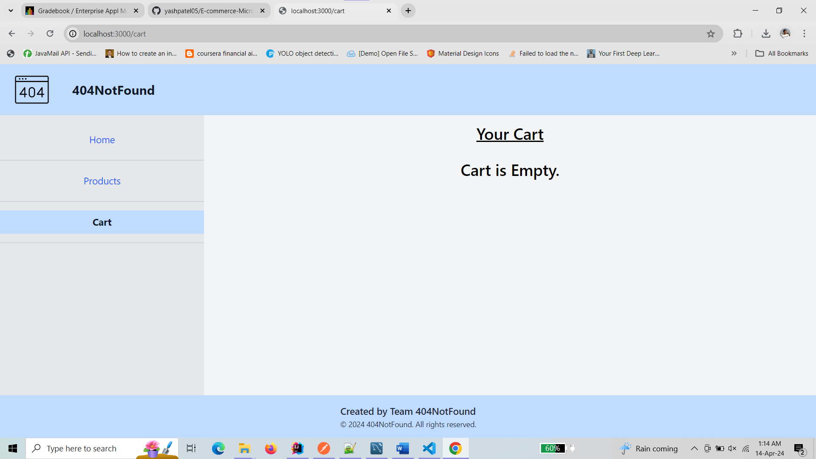

* Checkout: /checkout - Allows users to place orders.

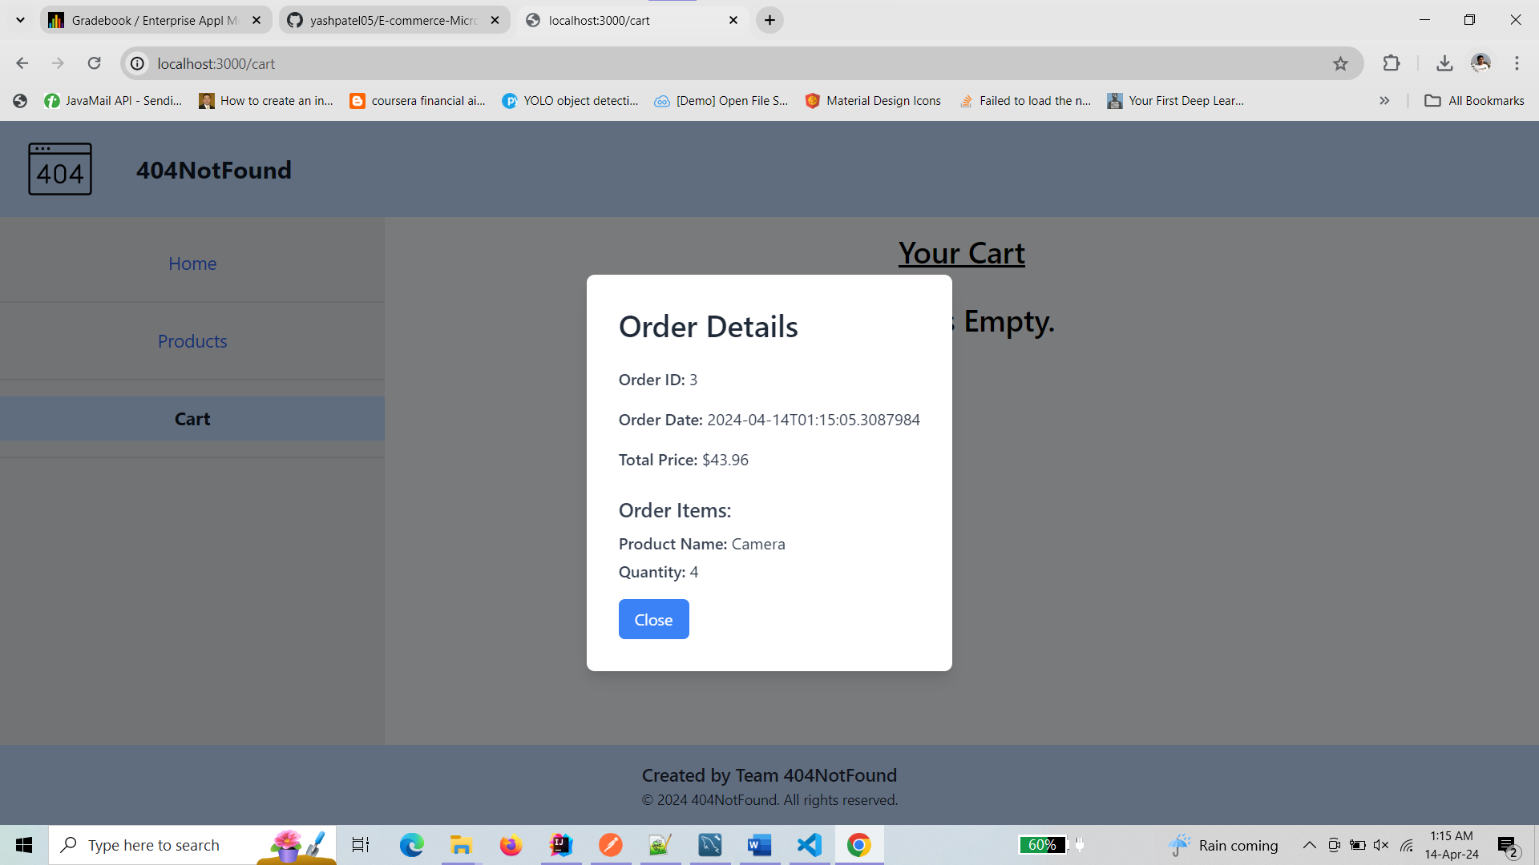

1. **Docker build screenshots :-**

* docker build -t admin-service -f Dockerfile-admin .

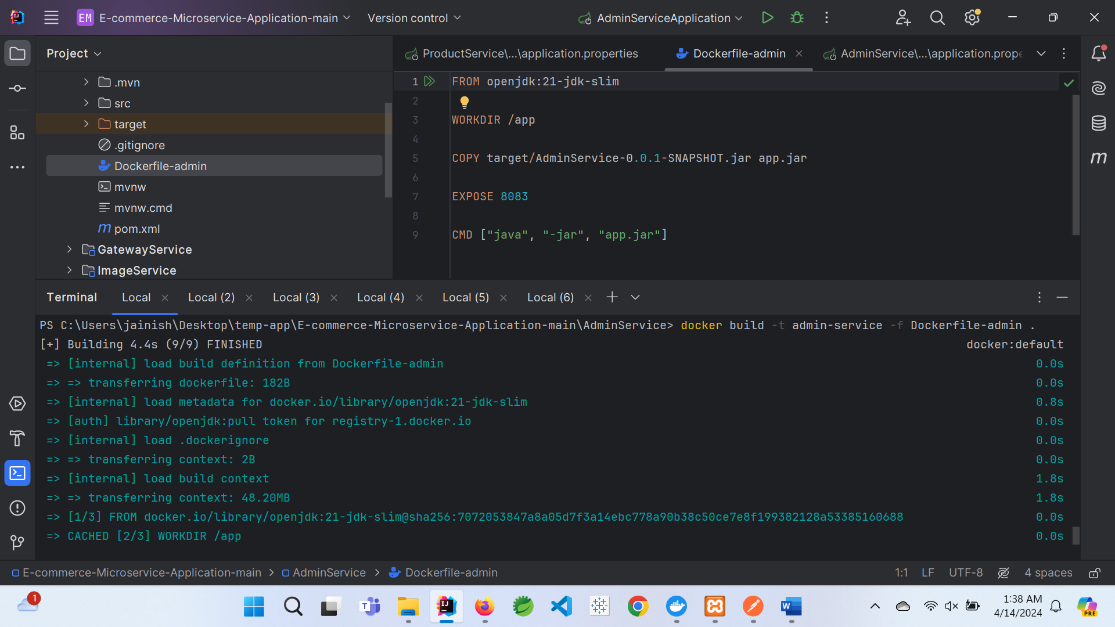

* docker build -t gateway-service -f Dockerfile-gateway .

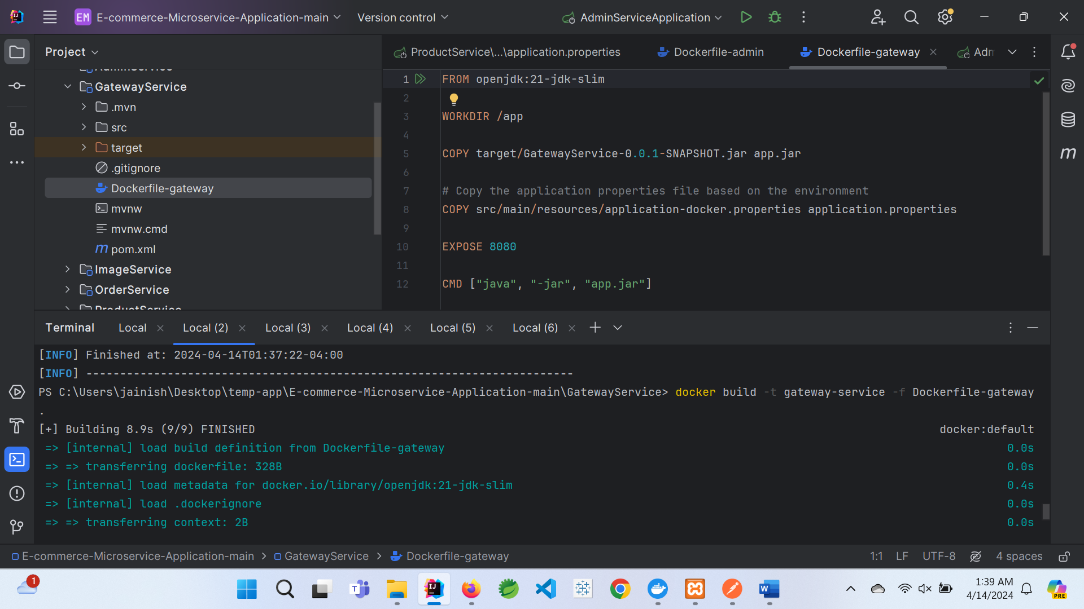

* docker build -t image-service -f Dockerfile-image .

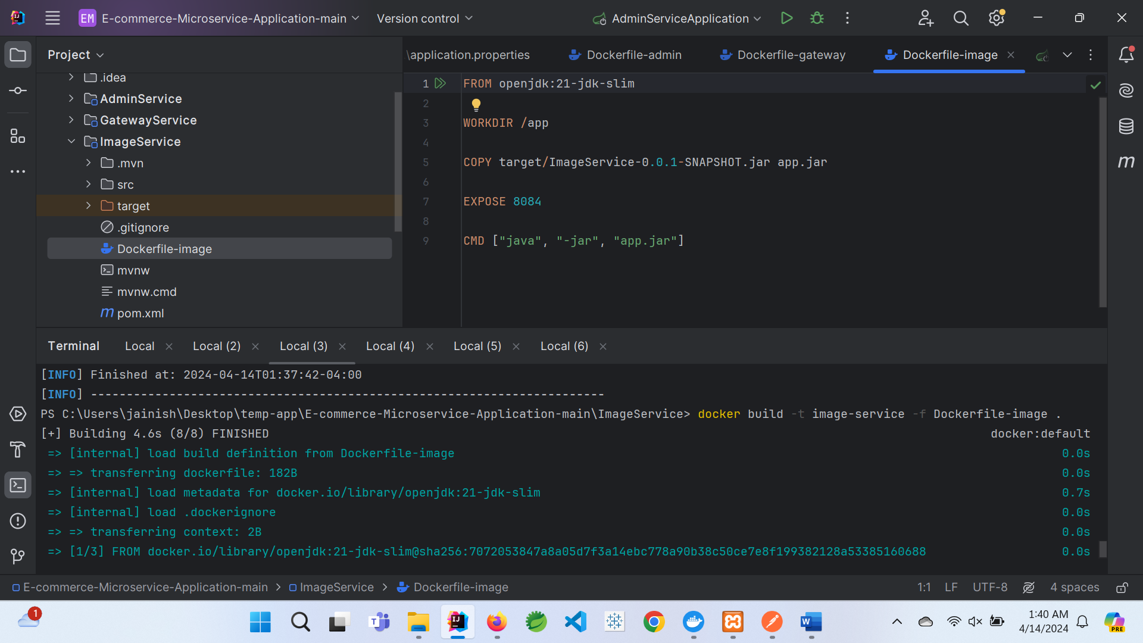

* docker build -t order-service -f Dockerfile-order .

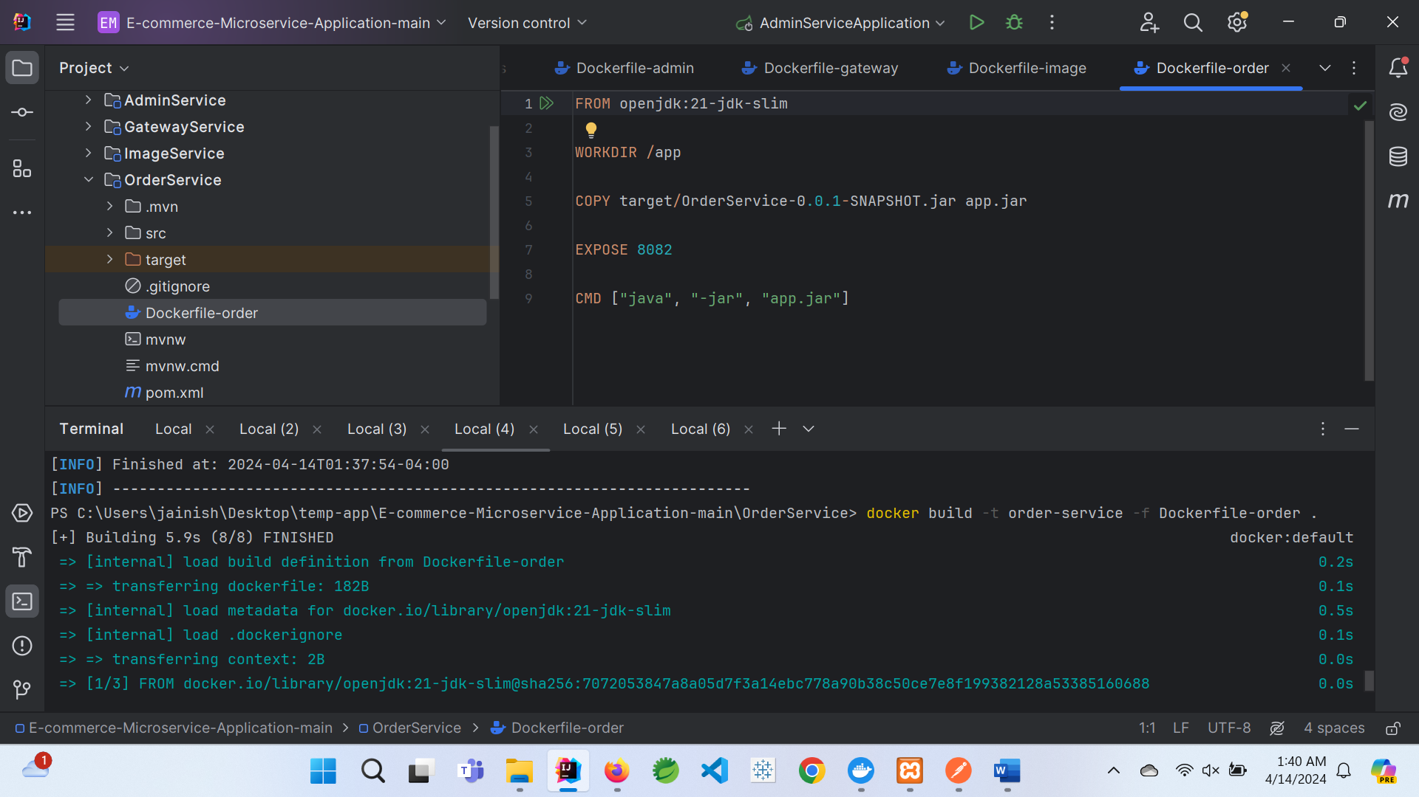

* docker build -t product-service -f Dockerfile-product .

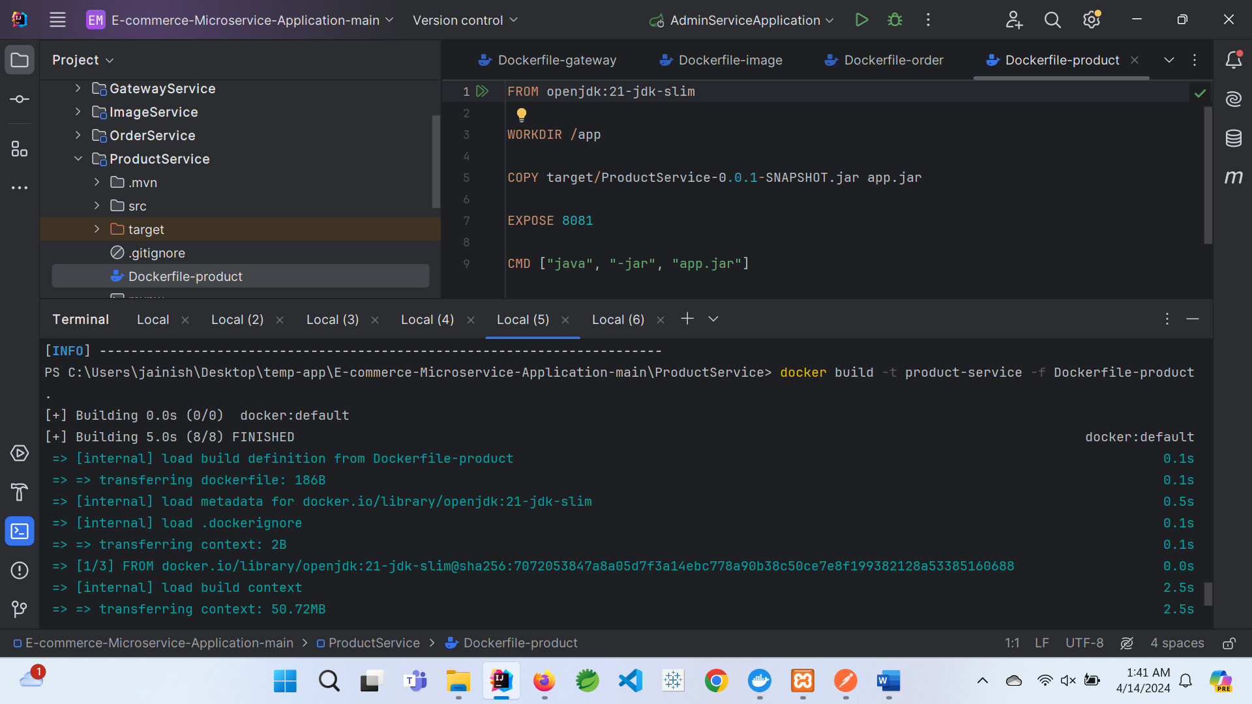

* All images in Docker:

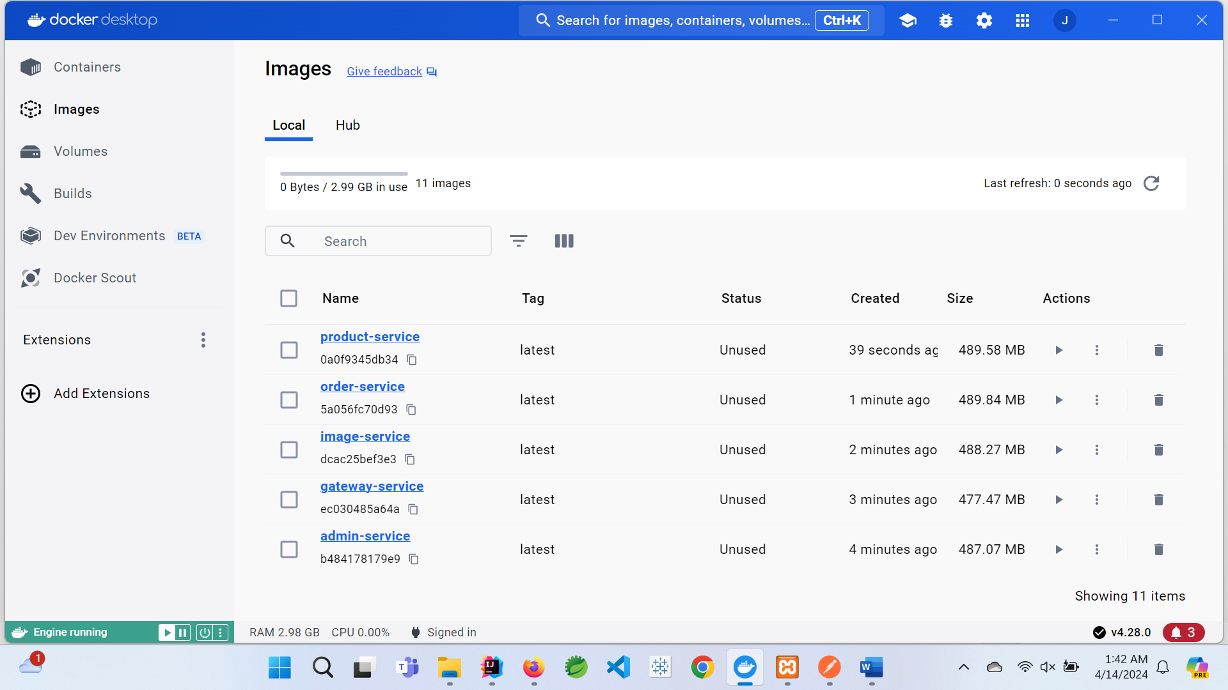

* docker-compose up:

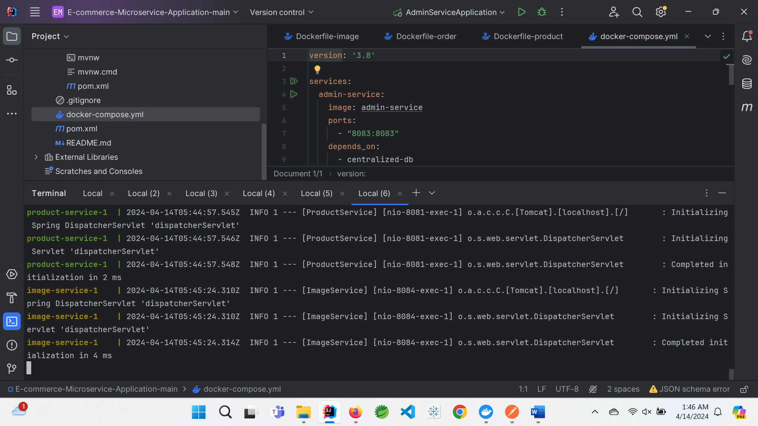

* container in docker:

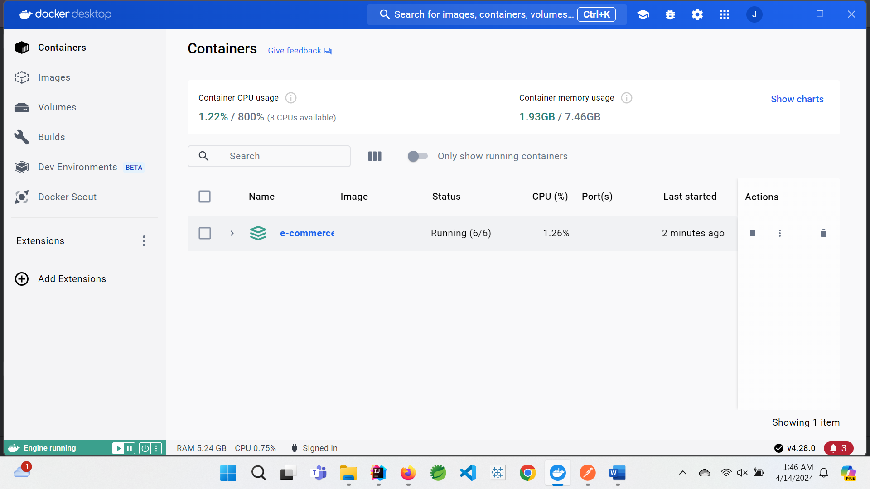

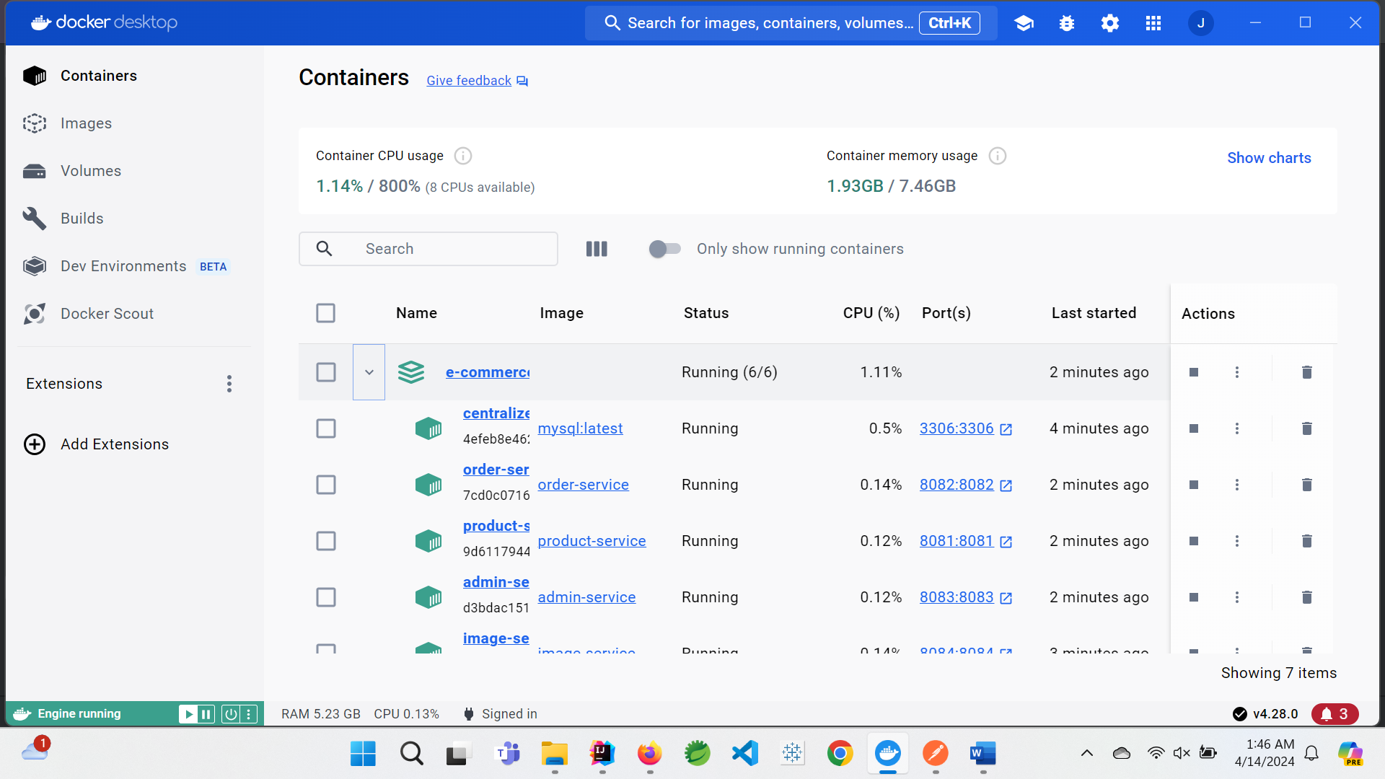

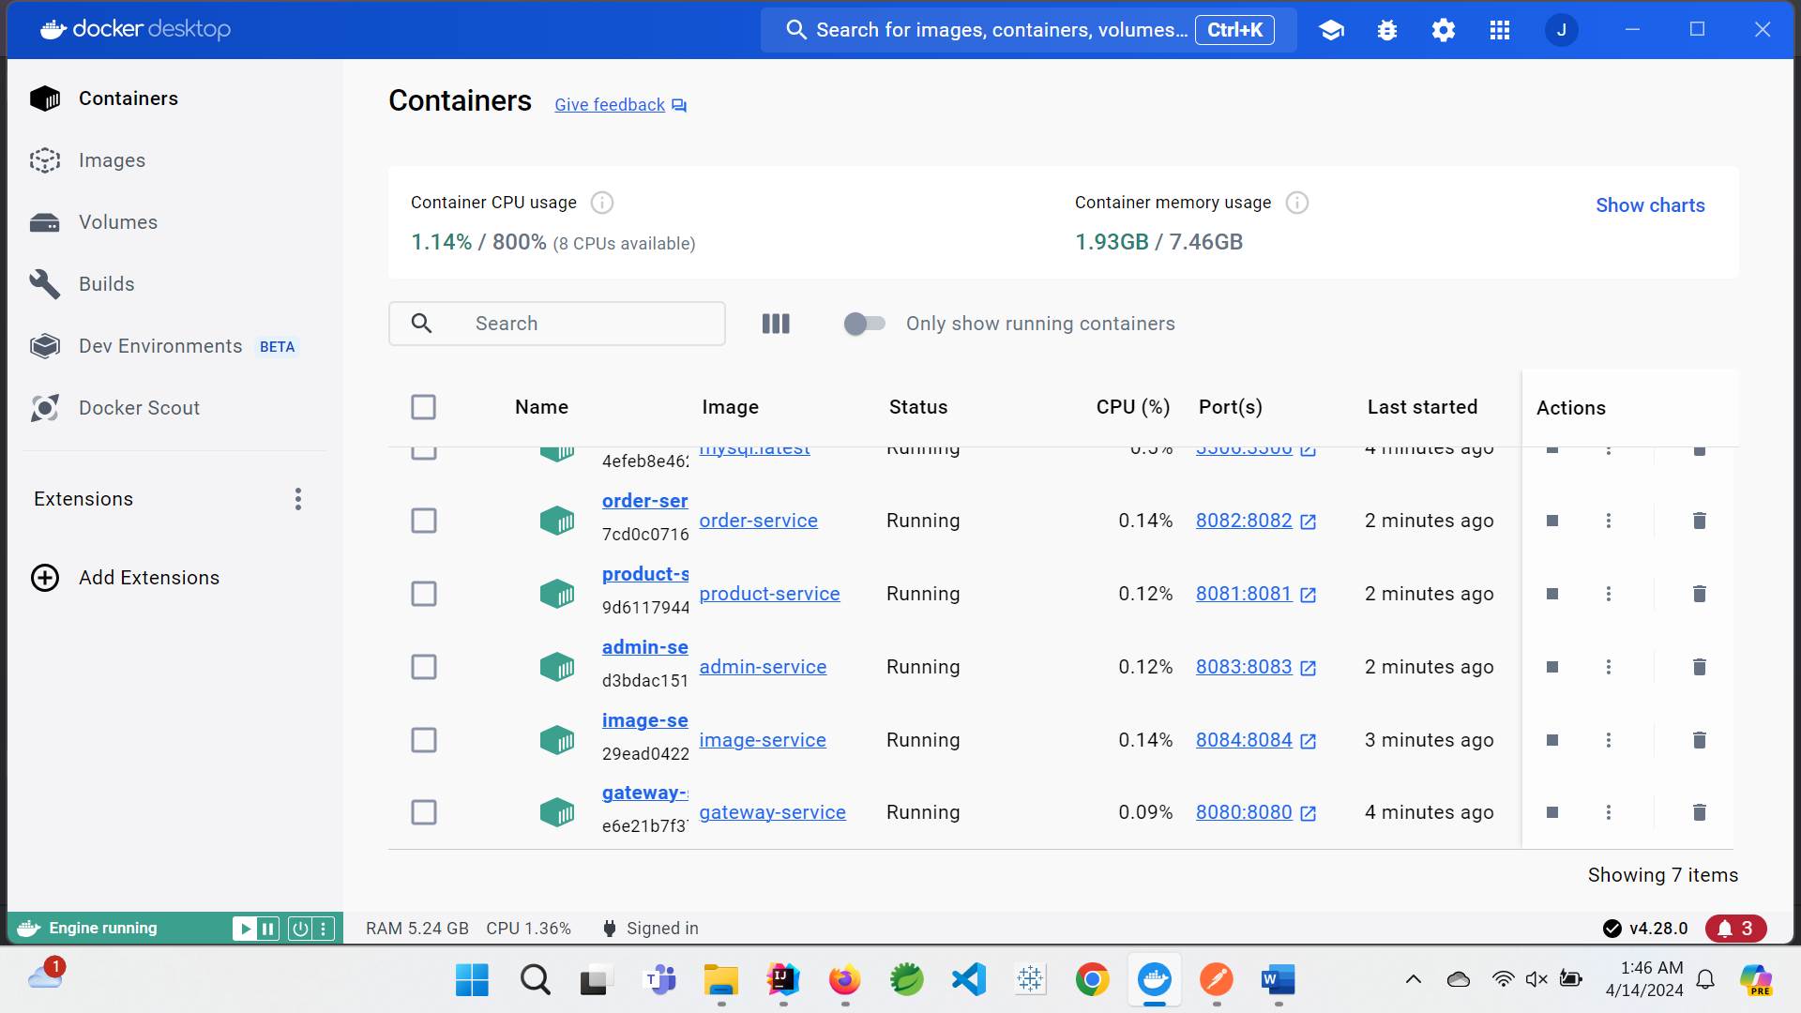

**For FrontEnd UI:**

* docker build -t e-commerce-frontend .

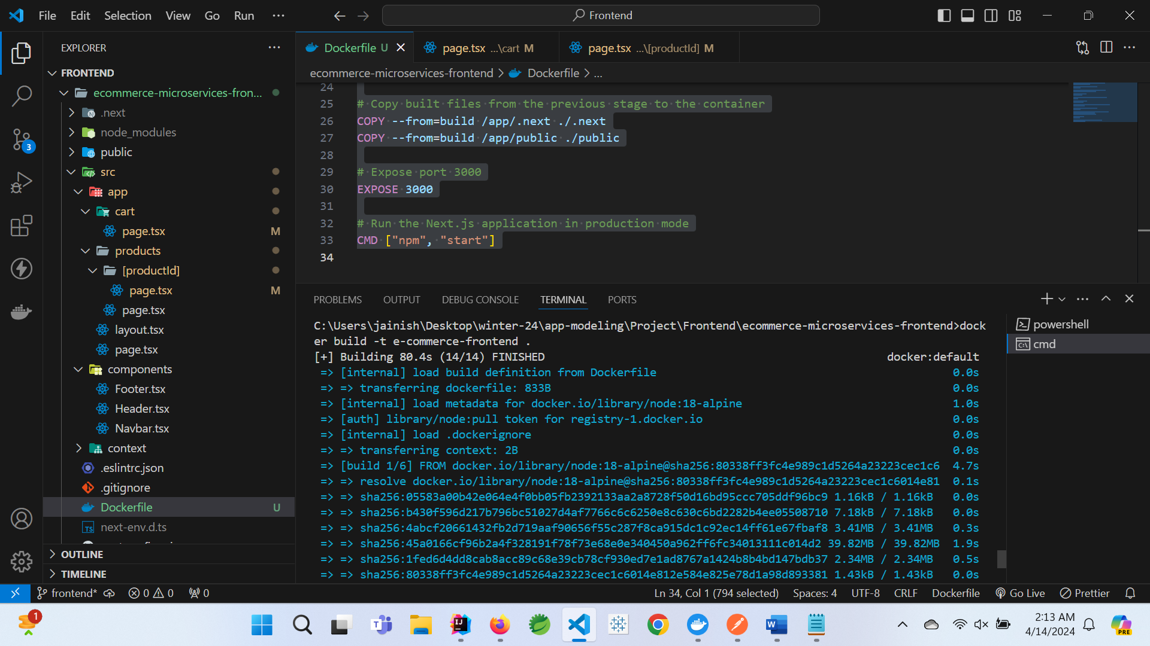

* Docker image for frontend:

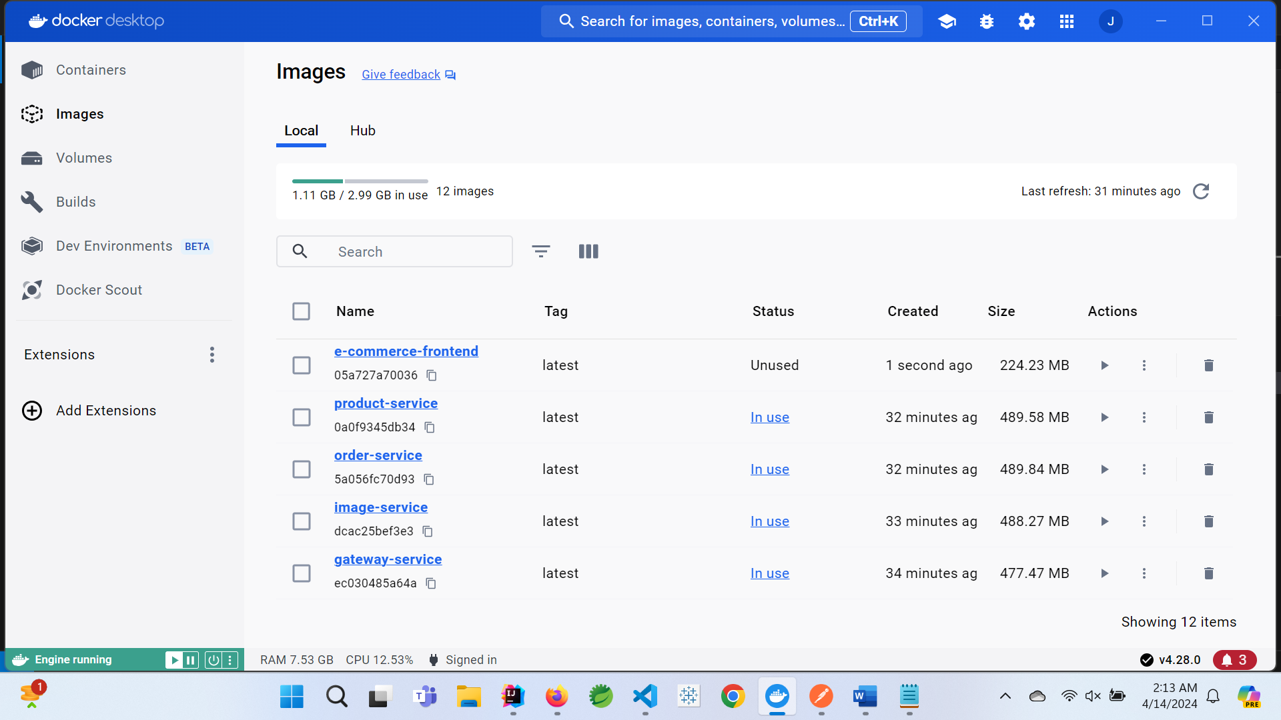

**container at frontend:**

* docker run -d -p 3000:3000 e-commerce-frontend

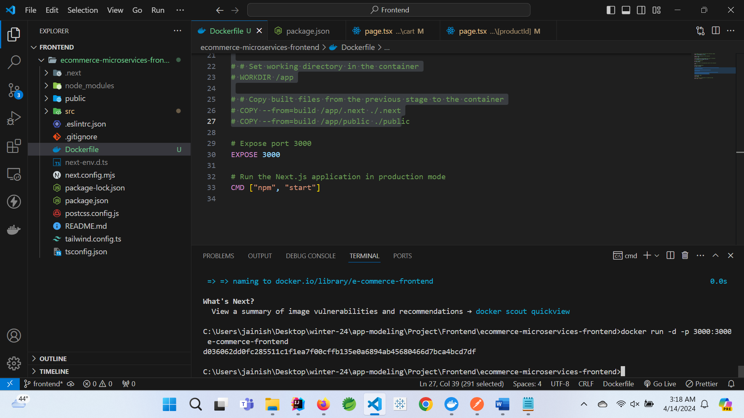

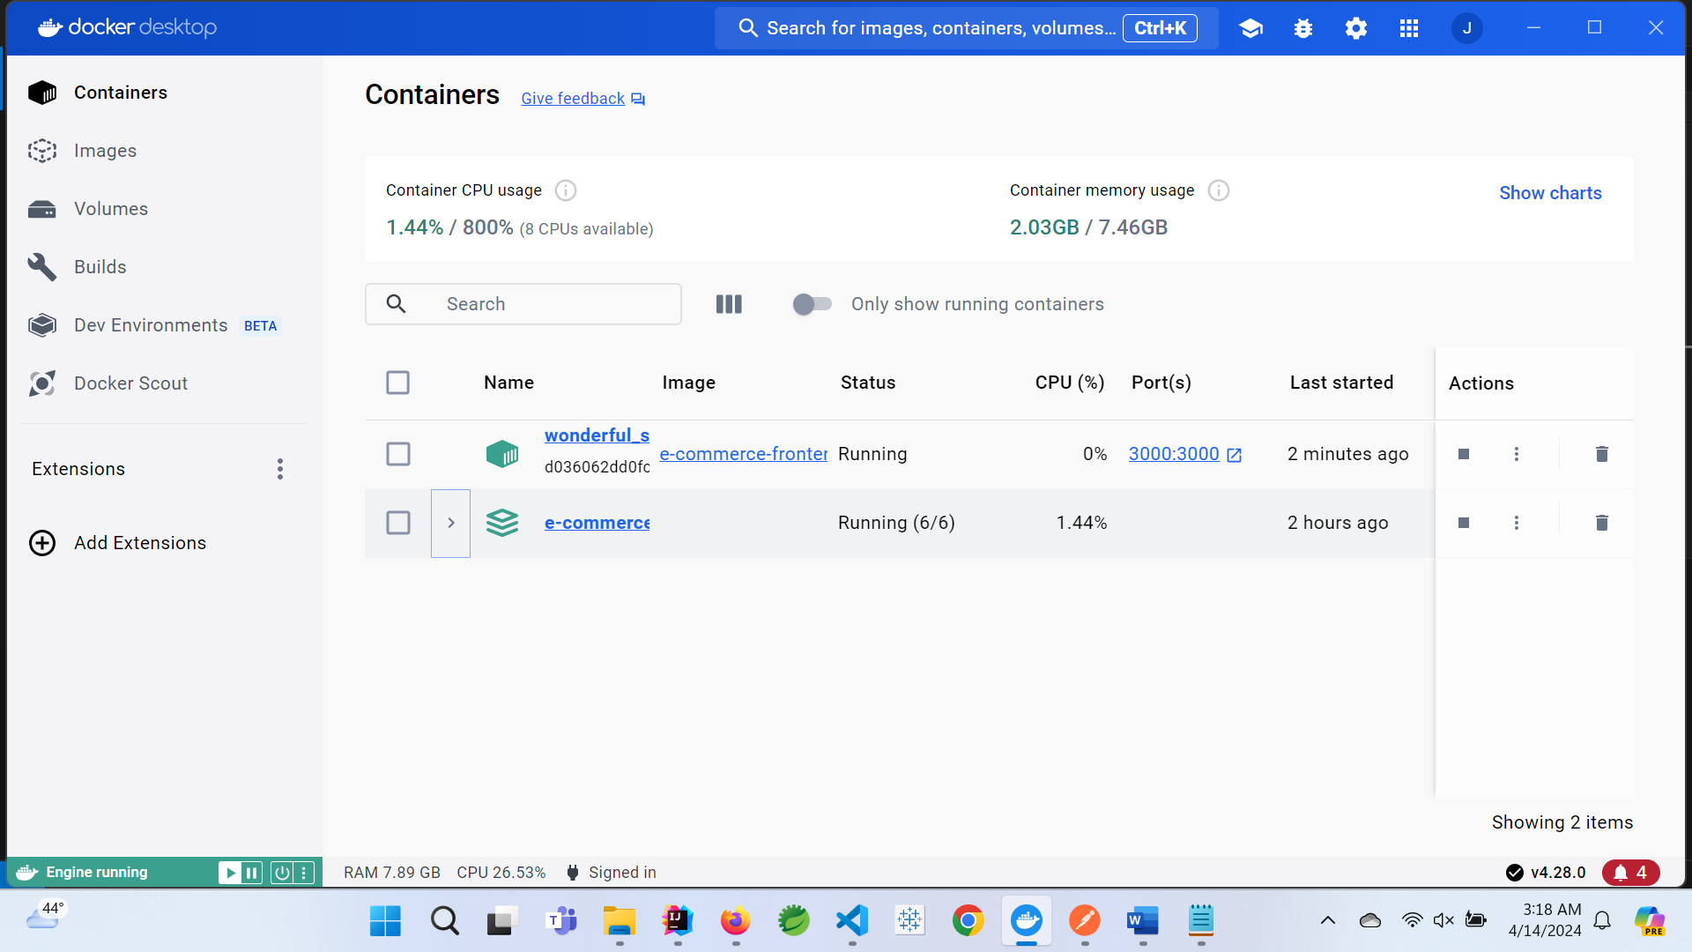

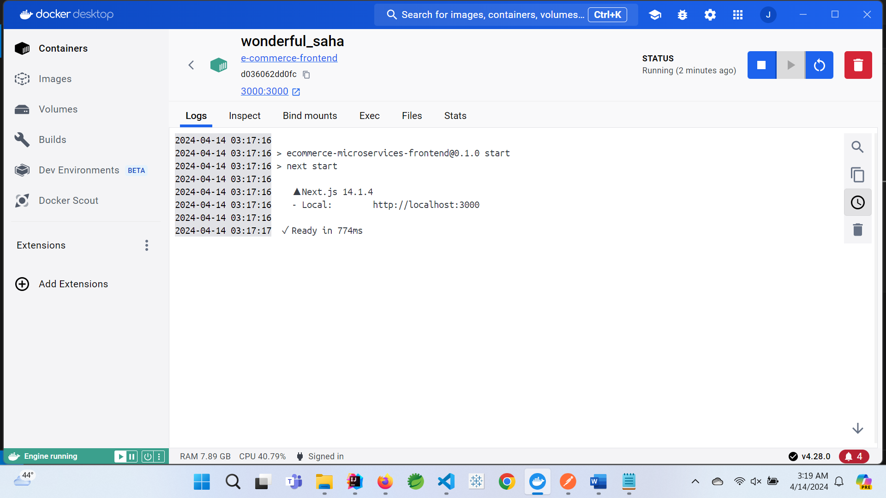

* <http://localhost:3000/> using docker containers:

